Filed by Factorial Inc.

Pursuant to Rule 425

under the Securities Act of 1933, as amended

and deemed filed pursuant to Rule 14a-12

under the Securities Exchange Act of 1934, as amended

Subject Company: Cartesian Growth Corporation III

(Commission File No. 001-42629)

Set forth below is a news article first made available on December 18, 2025 in connection with the proposed Business Combination.
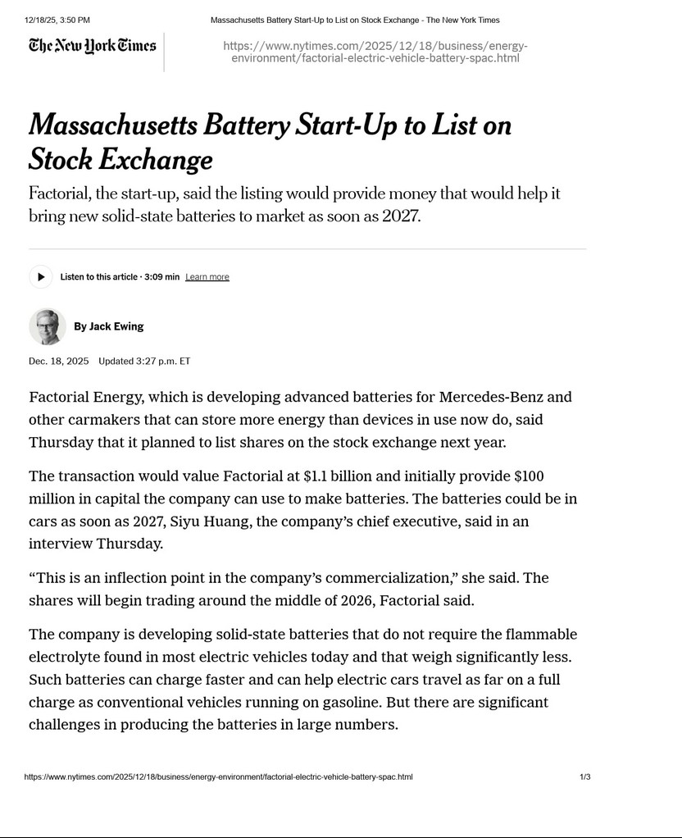

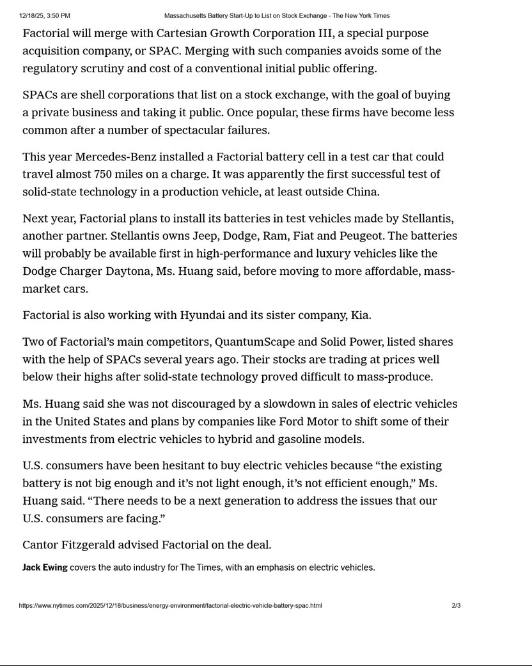



Set forth below are social media posts that Factorial uploaded to X and LinkedIn on December 18, 2025 in connection with the proposed Business Combination.
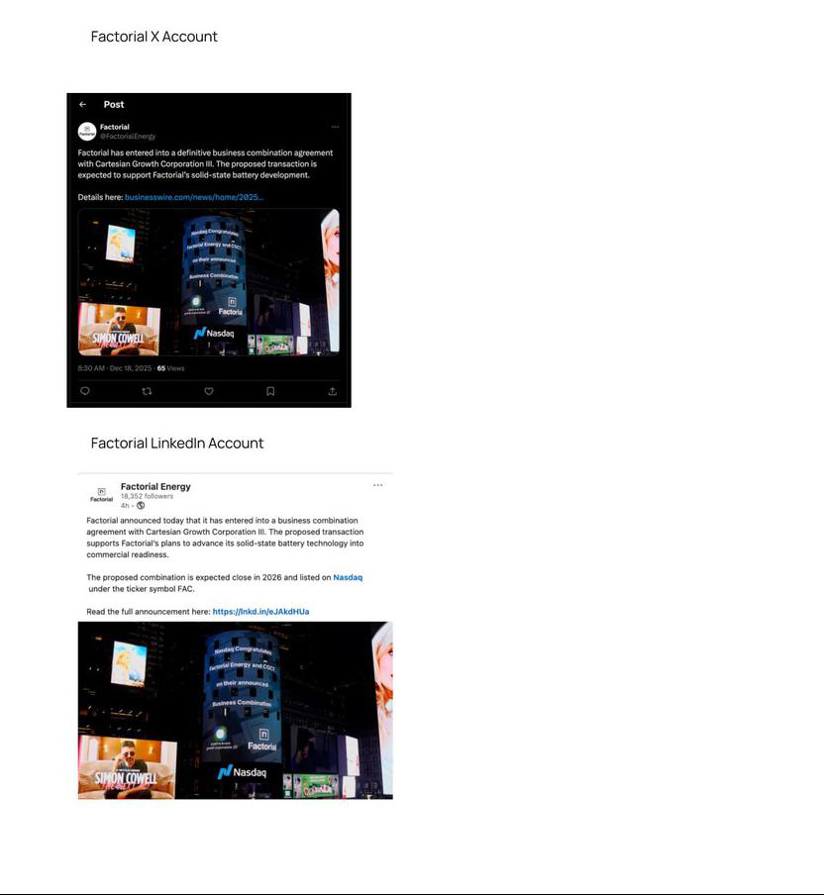

Set forth below is a social media post that Dr. Siyu Huang, Factorial's Co-founder and CEO, uploaded to LinkedIn on December 18, 2025 in connection with the proposed Business Combination.
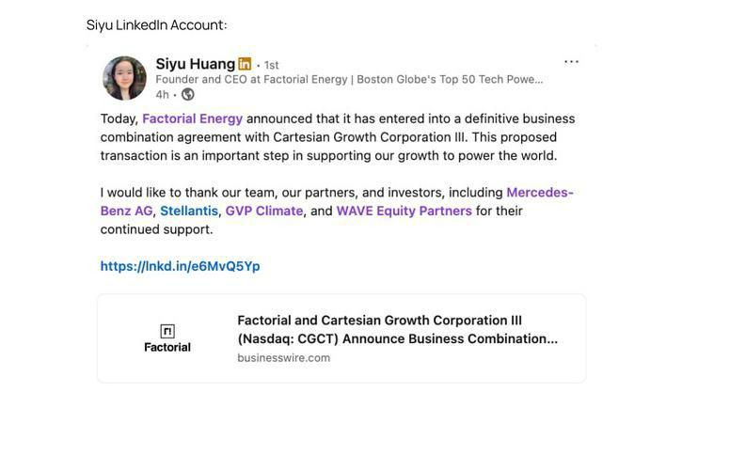

Set forth below is an internal company communication to employees and certain independent contractors of Factorial via email on December 18, 2025 in connection with the proposed Business Combination.
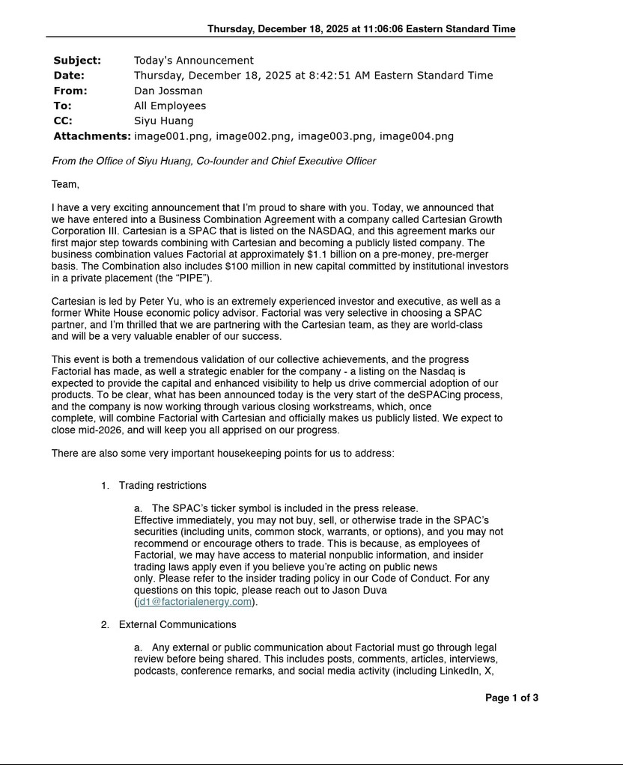

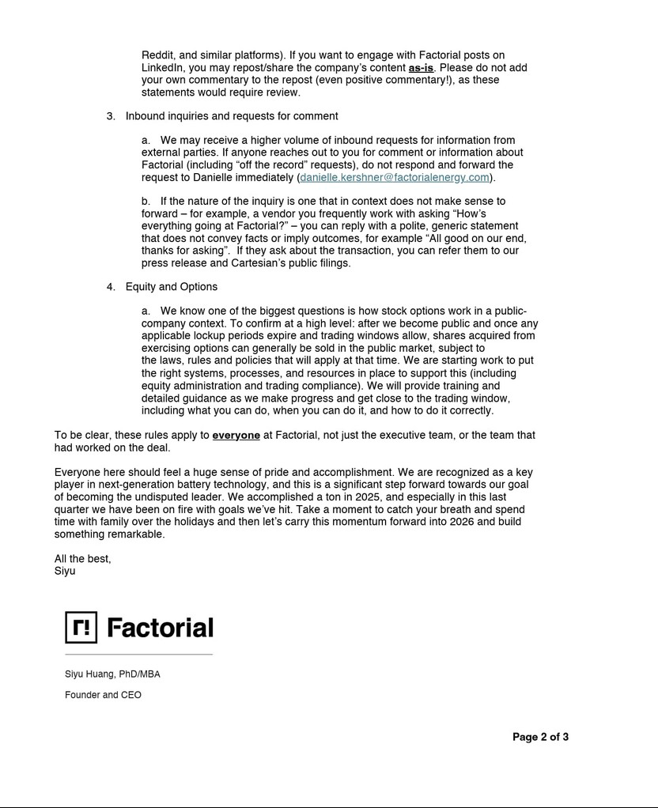



Additional Information about the Business Combination and Where to Find It

This communication relates to the proposed business combination (“Business Combination”) pursuant to that certain Business Combination Agreement (“BCA”), dated as of December 17, 2025, by and among Cartesian Growth Corporation III, a Cayman Islands exempted company (“CGC”), Fenway MS, Inc., a Delaware corporation (“Merger Sub”), and Factorial Inc., a Delaware corporation (“Factorial”). The proposed Business Combination will be submitted to shareholders of CGC for their consideration. CGC and Factorial intend to file a registration statement on Form S-4 with the Securities and Exchange Commission (“SEC”), which will include preliminary and definitive proxy statements to be distributed to CGC’s shareholders in connection with CGC’s solicitations of proxies from CGC’s shareholders with respect to the proposed business combination and other matters to be described in the registration statement, as well as the prospectus relating to the offer of the securities to be issued to the stockholders of Factorial in connection with the completion of the proposed Business Combination. After the registration statement has been filed and declared effective, CGC will mail a definitive proxy statement/prospectus and other relevant documents relating to the proposed Business Combination and other matters to be described in the registration statement to Factorial stockholders and CGC shareholders as of a record date to be established for voting on the proposed Business Combination. Before making any voting or investment decision, CGC shareholders, Factorial stockholders, and other interested persons are urged to read these documents and any amendments thereto, as well as any other relevant documents filed with the SEC by CGC in connection with the proposed Business Combination and other matters to be described in the registration statement, when they become available because they will contain important information about CGC, Factorial and the proposed Business Combination. Shareholders will also be able to obtain free copies of the preliminary proxy statement/prospectus, the definitive proxy statement/prospectus and other documents filed by CGC with the SEC, once available, without charge, at the SEC’s website located at www.sec.gov, or by directing a written request to Cartesian Growth Corporation III, 505 Fifth Avenue, 15th Floor, New York, New York 10017.

Forward-Looking Statements

This communication includes forward-looking statements. Forward-looking statements generally are accompanied by words such as “believe,” “may,” “will,” “estimate,” “continue,” “anticipate,” “intend,” “expect,” “should,” “would,” “plan,” “predict,” “potential,” “seem,” “seek,” “future,” “outlook” and similar expressions that predict or indicate future events or trends or that are not statements of historical matters. These forward-looking statements may include, but are not limited to, statements regarding estimates and forecasts of other financial and performance metrics and projections of market opportunity; financing, including the private placement of common stock in connection with the proposed Business Combination (the “PIPE”), and other business milestones; potential benefits of the proposed Business Combination and other related transactions; and expectations relating to the proposed Business Combination and other related transactions. These statements are based on various assumptions, whether or not identified in communication, and on the current expectations of Factorial’s and CGC’s management and are not predictions of actual performance. These forward-looking statements are provided for illustrative purposes only and are not intended to serve as and must not be relied on by an investor as a guarantee, an assurance, a prediction, or a definitive statement of fact or probability. Actual events and circumstances are difficult or impossible to predict and may differ from assumptions. Many actual events and circumstances are beyond the control of Factorial and CGC. These forward-looking statements are subject to a number of risks and uncertainties, including but not limited to changes in domestic and foreign business, market, financial, political, and legal conditions; the inability of the parties to successfully or timely consummate the proposed Business Combination and other related transactions, including the risk that any regulatory approvals are not obtained, are delayed or are subject to unanticipated conditions (such as any SEC statements or enforcement or other actions relating to SPACs) that could adversely affect the combined company or the expected benefits of the proposed Business Combination and other related transactions; failure to realize the anticipated benefits of the proposed Business Combination and other related transactions; ability to successfully consummate the PIPE, or obtain additional financing; ability to attract and retain qualified personnel; global economic and political conditions; the occurrence of any event, change or other circumstance that could give rise to the termination of the BCA; legal and regulatory changes; the outcome of any legal proceedings that may be instituted against CGC or Factorial related to the proposed Business Combination; the effects of competition on Factorial’s future business; the approval by CGC’s public shareholders of the Business Combination and related transactions, the amount of redemption requests made by CGC’s public shareholders. Additional risks related to Factorial’s business include, but are not limited to: the development of batteries is complex and the timing of development cannot be assured; delays in the development of its batteries could adversely affect Factorial’s business and prospects; Factorial may be unable to adequately control the costs associated with its operations and the components necessary to develop and commercialize its solid-state battery technology; Factorial may not be able to accurately estimate the future supply and demand for its batteries, which could result in a variety of inefficiencies in its business and hinder its ability to generate revenue and profits; Factorial’s expectations and targets regarding when it will achieve various technical, pre-production and production objectives depend in large part upon assumptions and analyses developed by Factorial, and if these assumptions or analyses prove to be incorrect, Factorial may not achieve these milestones when expected or at all; if Factorial’s existing customers with whom it has collaboration agreements do not make subsequent purchases from it, Factorial will not receive revenue from such customers, and its results of operations would be adversely impacted; Factorial is an early-stage company with a history of financial losses and expects to incur significant expenses and continuing losses from operations; Factorial’s business plan has yet to be tested, and it may not succeed in executing on its strategic plans, including commercialization; Factorial relies heavily on its intellectual property portfolio, and if it is unable to protect its intellectual property rights, Factorial’s business and competitive position would be harmed; Factorial’s patent applications may not result in issued patents or its patent rights may be contested, circumvented, invalidated or limited in scope, any of which could have a material adverse effect on its ability to prevent others from interfering with its commercialization of its products; governmental trade controls, including export and import controls, sanctions, customs requirements and related regimes, could subject Factorial to liability or loss of contracting privileges, limit its ability to transfer technology or compete in certain markets and affect its ability to hire qualified personnel; and changes in U.S. and foreign government policy, including the imposition of or increases in tariffs and changes to existing trade agreements, could have a material adverse effect on global economic conditions and Factorial’s business, financial condition, results of operations and prospects. Additional risks related to CGC include those factors set forth in the section entitled “Risk Factors” and “Cautionary Note Regarding Forward-Looking Statements” in CGC’s final prospectus for its initial public offering filed with the SEC on May 5, 2025 (“CGC IPO Final Prospectus”), and in those documents that CGC has filed, or will file, with the SEC. If any of these risks materialize or CGC’s or Factorial’s assumptions prove incorrect, actual results could differ materially from the results implied by these forward-looking statements. There may be additional risks that neither CGC nor Factorial presently know or that CGC and Factorial currently believe are immaterial that could also cause actual results to differ from those contained in the forward-looking statements. In addition, forward-looking statements reflect CGC’s and Factorial’s expectations, plans, or forecasts of future events and views as of the date of this communication and are qualified in their entirety by reference to the cautionary statements herein. CGC and Factorial anticipate that subsequent events and developments will cause CGC’s and Factorial’s assessments to change. These forward-looking statements should not be relied upon as representing CGC’s and Factorial’s assessments as of any date subsequent to the date of this communication. Accordingly, undue reliance should not be placed upon the forward-looking statements. Neither CGC, Factorial nor any of their respective affiliates undertake any obligation to update these forward-looking statements, except as required by law.

Participants in the Solicitation

CGC, Factorial, and their respective directors and executive officers may be deemed to be participants in the solicitations of proxies from CGC’s shareholders with respect to the proposed Business Combination and the other matters set forth in the registration statement. Information regarding CGC’s directors and executive officers, and a description of their interests in CGC is contained in the CGC IPO Final Prospectus, which was filed with the SEC and is available free of charge at the SEC’s website located at www.sec.gov, or by directing a request to Cartesian Growth Corporation III, 505 Fifth Avenue, 15th Floor, New York, New York 10017. Additional information regarding the interests of such participants in the proxy solicitation and a description of their direct and indirect interests, will be contained in the proxy statement/prospectus relating to the proposed Business Combination when it becomes available. Shareholders, potential investors and other interested persons should read the proxy statement/prospectus carefully when it becomes available before making any voting or investment decisions. You may obtain free copies of these documents from the sources described above.

This communication is not a substitute for the registration statement or for any other document that CGC and Factorial may file with the SEC in connection with the proposed Business Combination. INVESTORS AND SECURITY HOLDERS ARE URGED TO READ THE DOCUMENTS FILED WITH THE SEC CAREFULLY AND IN THEIR ENTIRETY WHEN THEY BECOME AVAILABLE BECAUSE THEY WILL CONTAIN IMPORTANT INFORMATION. Investors and security holders may obtain free copies of other documents filed with the SEC by CGC, without charge, at the SEC’s website located at www.sec.gov.

No Offer or Solicitation

This communication shall not constitute an offer to sell, or the solicitation of an offer to buy, or a recommendation to purchase, any securities, in any jurisdiction, or the solicitation of any vote, consent or approval in any jurisdiction in connection with the proposed Business Combination or any related transactions, nor shall there be any sale of securities in any states or jurisdictions in which such offer, solicitation or sale would be unlawful. This communication is not, and under no circumstances is to be construed as, a prospectus, an advertisement or a public offering of the securities described herein in the United States or any other jurisdiction. No offer of securities shall be made except by means of a prospectus meeting the requirements of Section 10 of the Securities Act, or exemptions therefrom. INVESTMENT IN ANY SECURITIES DESCRIBED HEREIN HAS NOT BEEN APPROVED BY THE SEC OR ANY OTHER REGULATORY AUTHORITY NOR HAS ANY AUTHORITY PASSED UPON OR ENDORSED THE MERITS OF THE OFFERING OR THE ACCURACY OR ADEQUACY OF THE INFORMATION CONTAINED HEREIN. ANY REPRESENTATION TO THE CONTRARY IS A CRIMINAL OFFENSE.

