UNITED STATES
SECURITIES AND EXCHANGE COMMISSION
Washington, D.C. 20549
FORM 8-K
CURRENT REPORT
Pursuant to Section 13 or 15(d)
of the Securities Exchange Act of 1934
Date of Report (Date of earliest event reported): August 11, 2026
FACTORIAL ENERGY INC.
(Exact name of registrant as specified in its charter)
Delaware |  |  |  |  |  | 001-42629 |  |  |  |  |  | 42-2967285
(State or other jurisdiction  of incorporation) |  |  |  |  |  | (Commission File Number) |  |  |  |  |  | (IRS Employer  Identification No.)
805 Middlesex Turnpike
Billerica, MA 01821
(Address of principal executive offices including zip code)
Registrant’s telephone number, including area code: (617) 315-9733
Not Applicable
(Former name or former address, if changed since last report)
Check the appropriate box below if the Form 8-K filing is intended to simultaneously satisfy the filing obligation of the registrant under any of the following provisions:
☐ |  |  | Written communications pursuant to Rule 425 under the Securities Act (17 CFR 230.425)
☐ |  |  | Soliciting material pursuant to Rule 14a-12 under the Exchange Act (17 CFR 240.14a-12)
☐ |  |  | Pre-commencement communications pursuant to Rule 14d-2(b) under the Exchange Act (17 CFR 240.14d-2(b))
☐ |  |  | Pre-commencement communications pursuant to Rule 13e-4(c) under the Exchange Act (17 CFR 240.13e-4(c))
Securities registered pursuant to Section 12(b) of the Act:
Title of each class |  |  |  |  |  | Trading  Symbol |  |  |  |  |  | Name of each exchange  on which registered
Series A Common Stock, par value $0.00001 per share |  |  |  |  |  | FAC |  |  |  |  |  | The Nasdaq Global Market
Warrants, each whole warrant exercisable for one share of Series A Common Stock at an exercise price of $11.50 |  |  |  |  |  | FACWW |  |  |  |  |  | The Nasdaq Global Market
Indicate by check mark whether the registrant is an emerging growth company as defined in Rule 405 of the Securities Act of 1933 (§230.405 of this chapter) or Rule 12b-2 of the Securities Exchange Act of 1934 (§240.12b-2 of this chapter).
Emerging growth company x
If an emerging growth company, indicate by check mark if the registrant has elected not to use the extended transition period for complying with any new or revised financial accounting standards provided pursuant to Section 13(a) of the Exchange Act. ☐

Item 2.02. Results of Operations and Financial Condition.
On August 11, 2026, Factorial Energy Inc. (the “Company”) issued a press release and a shareholder letter announcing its financial results for the quarter ended June 30, 2026. Cop=ies of the press release and the shareholder letter are attached as Exhibits 99.1 and 99.2.
The information in this Item 2.02 of this Current Report on Form 8-K, including Exhibits 99.1 and 99.2, is being furnished and shall not be deemed “filed” for the purposes of Section 18 of the Securities Exchange Act of 1934, as amended (“Exchange Act”) or otherwise subject to the liabilities of that section, nor shall such information be deemed incorporated by reference in any filing under the Exchange Act or the Securities Act of 1933, as amended, regardless of the general incorporation language of such filing, except as shall be expressly set forth by specific reference in such filing.

Item 7.01. Regulation FD Disclosure.
On August 11, 2026, the Company released an updated investor presentation. The presentation is attached hereto as Exhibit 99.3 and is being furnished, not filed, under Item 7.01 of this Current Report on Form 8-K.

Item 9.01. Financial Statements and Exhibits
(d) Exhibits. The exhibits shall be deemed to be filed or furnished, depending on the relevant item requiring such exhibit, in accordance with the provisions of Item 601 of Regulation S-K (17 CFR 229.601) and Instruction B.2 to this form.
Exhibit  No. |  |  |  |  |  | Description
99.1 |  |  |  |  |  | Press release, dated August 11, 2026
99.2 |  |  |  |  |  | Shareholder letter, dated August 11, 2026
99.3 |  |  |  |  |  | Investor Presentation, dated August 11, 2026
104 |  |  |  |  |  | Cover Page Interactive Data File (embedded within the Inline XBRL document)

SIGNATURE
Pursuant to the requirements of the Exchange Act, the registrant has duly caused this report to be signed on its behalf by the undersigned hereunto duly authorized.
FACTORIAL ENERGY INC.
By: |  |  | /s/ Siyu Huang
Name: |  |  | Siyu Huang
Title: |  |  | Chief Executive Officer
Date: |  |  | August 11, 2026

Exhibit 99.1

Factorial Announces Second Quarter 2026 Results

BOSTON, MA – August 11, 2026 — Factorial Energy Inc. (“Factorial”) (Nasdaq: FAC), a global leader in solid-state battery technology, today announced financial and business results for the second quarter ended June 30, 2026.
The Company has issued a shareholder letter discussing its second quarter 2026 financial and business results, and recent highlights. The shareholder letter may be accessed on the Investors section of Factorial’s website at https://ir.factorialenergy.com/.
Factorial will host a conference call today at 4:30 PM ET to discuss the Company’s financial results. The live webcast of the conference call can be accessed through the Investors section of Factorial’s website. For those unable to access the webcast, the conference call can be accessed by dialing 1-877-407-9716 (domestic) or 1-201-493-6779 (international). To access the replay of the call, dial 1-844-512-2921 (domestic) or 1-412-317-6671 (international) and enter pass code 13761769.
About Factorial Energy
Factorial Energy (Nasdaq: FAC) is a leading American solid-state battery innovator backed by IQT - the not-for-profit strategic investor for the U.S. national security community and America’s allies – and Mercedes-Benz, Stellantis, Hyundai, and Kia. Through its proprietary FEST® and Solstice™ platforms, engineered for scalable manufacturing, Factorial delivers industry-leading performance across aerospace, energy storage and mobility applications. Mercedes-Benz’ real-world road testing in a lightly modified test vehicle achieved over 1,200 km of range on a single charge, while Stellantis-lab testing verified 77 Ah cells demonstrating high energy density, fast-charging, and robust use for energy and power performance across temperature extremes with the technology successfully integrated into a Dodge Charger Daytona demonstration vehicle. For more information visit www.factorialenergy.com.
Forward-Looking Statements
Certain statements in this communication may be considered “forward-looking statements.” Forward-looking statements herein generally relate to future events or the future financial or operating performance of Factorial. For example, Factorial’s expectations regarding future financial performance, manufacturing capabilities and operations, Factorial’s business plans, and other projections concerning key performance metrics or milestones are forward-looking statements. In some cases, you can identify forward-looking statements by terminology such as “may,” “should,” “expect,” “intend,” “will,” “estimate,” “anticipate,” “believe,” “predict,” “project,” “target,” “plan,” or “potentially” or the negatives of these terms or variations of them or similar terminology. Such forward-looking statements are subject to risks, uncertainties, and other factors which could cause actual results to differ materially from those expressed or implied by such forward-looking statements. While Factorial may elect to update such forward-looking statements in the future, it disclaims any obligation to do so.

Factorial IR Contact: IR@factorialenergy.com
Factorial Media Contact: Factorial@antennagroup.com
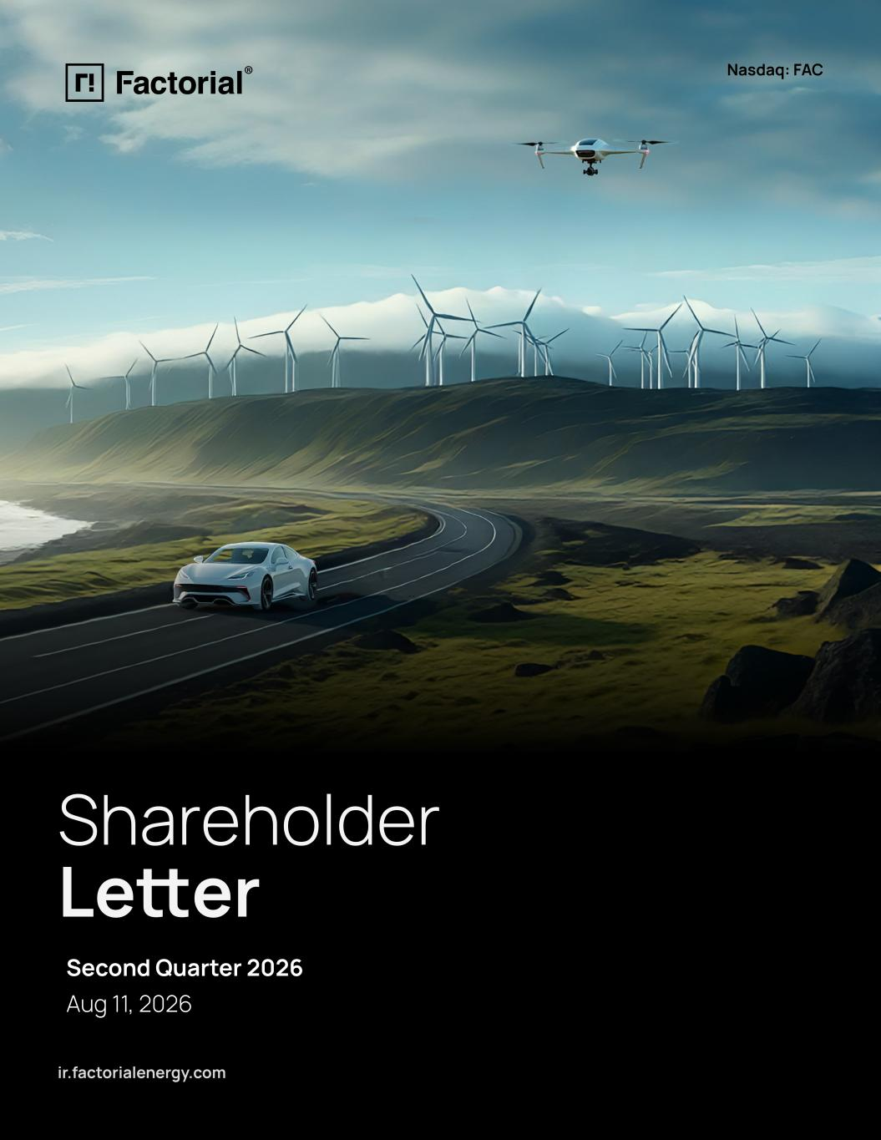
1
Nasdaq: FAC Shareholder Letter ir.factorialenergy.com Second Quarter 2026 Aug 11, 2026

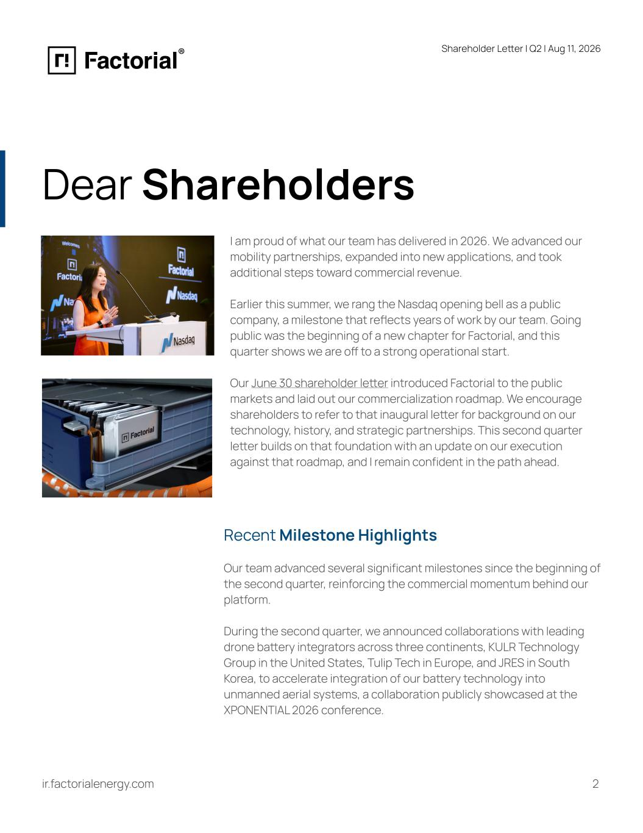
Shareholder Letter I Q2 | Aug 11, 2026 Dear Shareholders I am proud of what our team has delivered in 2026. We advanced our mobility partnerships, expanded into new applications, and took additional steps toward commercial revenue. Earlier this summer, we rang the Nasdaq opening bell as a public company, a milestone that reflects years of work by our team. Going public was the beginning of a new chapter for Factorial, and this quarter shows we are off to a strong operational start. Our June 30 shareholder letter introduced Factorial to the public markets and laid out our commercialization roadmap. We encourage shareholders to refer to that inaugural letter for background on our technology, history, and strategic partnerships. This second quarter letter builds on that foundation with an update on our execution against that roadmap, and I remain confident in the path ahead. Recent Milestone Highlights Our team advanced several significant milestones since the beginning of the second quarter, reinforcing the commercial momentum behind our platform. During the second quarter, we announced collaborations with leading drone battery integrators across three continents, KULR Technology Group in the United States, Tulip Tech in Europe, and JRES in South Korea, to accelerate integration of our battery technology into unmanned aerial systems, a collaboration publicly showcased at the XPONENTIAL 2026 conference. 2ir.factorialenergy.com

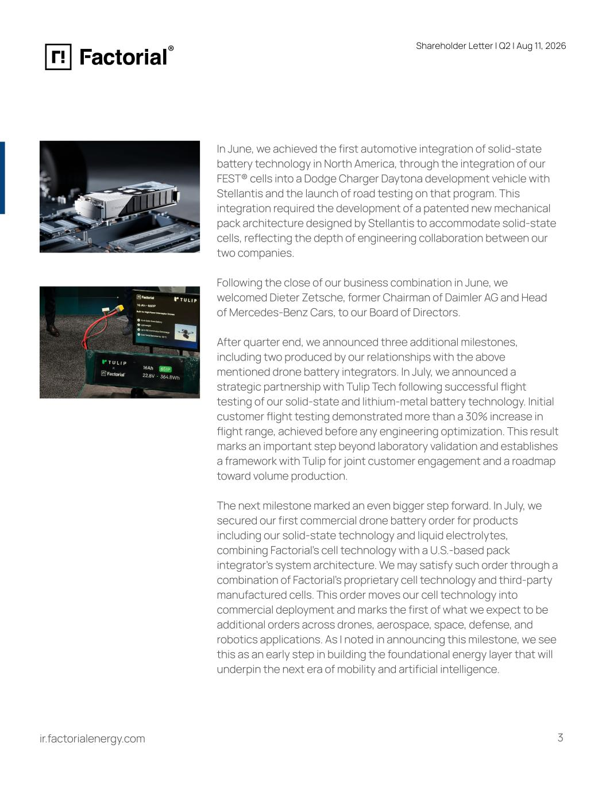
Shareholder Letter I Q2 | Aug 11, 2026 ir.factorialenergy.com In June, we achieved the first automotive integration of solid-state battery technology in North America, through the integration of our FEST® cells into a Dodge Charger Daytona development vehicle with Stellantis and the launch of road testing on that program. This integration required the development of a patented new mechanical pack architecture designed by Stellantis to accommodate solid-state cells, reflecting the depth of engineering collaboration between our two companies. Following the close of our business combination in June, we welcomed Dieter Zetsche, former Chairman of Daimler AG and Head of Mercedes-Benz Cars, to our Board of Directors. After quarter end, we announced three additional milestones, including two produced by our relationships with the above mentioned drone battery integrators. In July, we announced a strategic partnership with Tulip Tech following successful flight testing of our solid-state and lithium-metal battery technology. Initial customer flight testing demonstrated more than a 30% increase in flight range, achieved before any engineering optimization. This result marks an important step beyond laboratory validation and establishes a framework with Tulip for joint customer engagement and a roadmap toward volume production. The next milestone marked an even bigger step forward. In July, we secured our first commercial drone battery order for products including our solid-state technology and liquid electrolytes, combining Factorial's cell technology with a U.S.-based pack integrator’s system architecture. We may satisfy such order through a combination of Factorial’s proprietary cell technology and third-party manufactured cells. This order moves our cell technology into commercial deployment and marks the first of what we expect to be additional orders across drones, aerospace, space, defense, and robotics applications. As I noted in announcing this milestone, we see this as an early step in building the foundational energy layer that will underpin the next era of mobility and artificial intelligence. 3

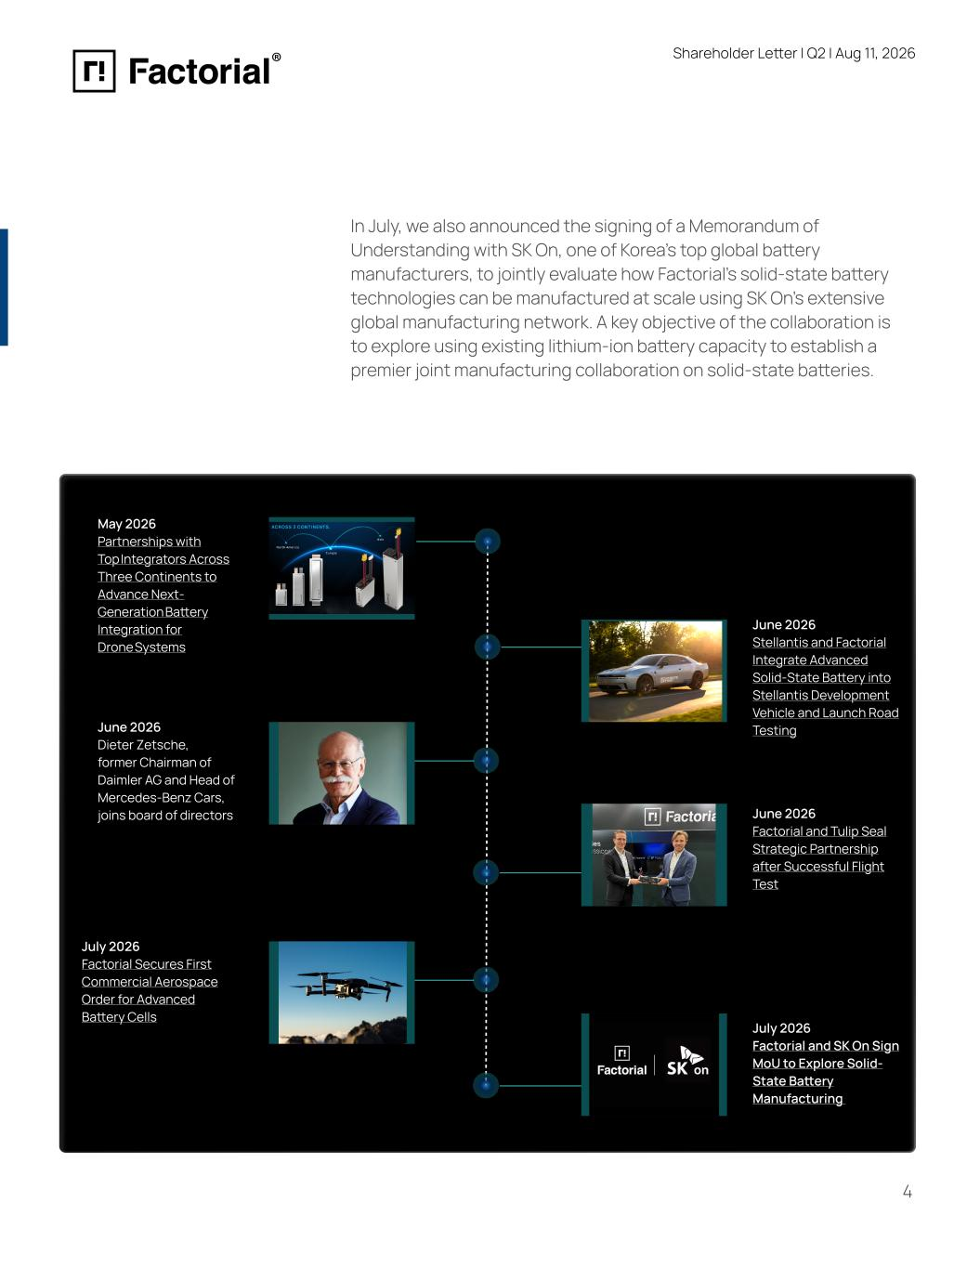
Shareholder Letter I Q2 | Aug 11, 2026 In July, we also announced the signing of a Memorandum of Understanding with SK On, one of Korea's top global battery manufacturers, to jointly evaluate how Factorial's solid-state battery technologies can be manufactured at scale using SK On's extensive global manufacturing network. A key objective of the collaboration is to explore using existing lithium-ion battery capacity to establish a premier joint manufacturing collaboration on solid-state batteries. May 2026 Partnerships with Top Integrators Across Three Continents to Advance Next- Generation Battery Integration for Drone Systems June 2026 Dieter Zetsche, former Chairman of Daimler AG and Head of Mercedes-Benz Cars, joins board of directors June 2026 Stellantis and Factorial Integrate Advanced Solid-State Battery into Stellantis Development Vehicle and Launch Road Testing June 2026 Factorial and Tulip Seal Strategic Partnership after Successful Flight Test July 2026 Factorial Secures First Commercial Aerospace Order for Advanced Battery Cells July 2026 Factorial and SK On Sign MoU to Explore Solid- State Battery Manufacturing 4 ir.factorialenergy.com

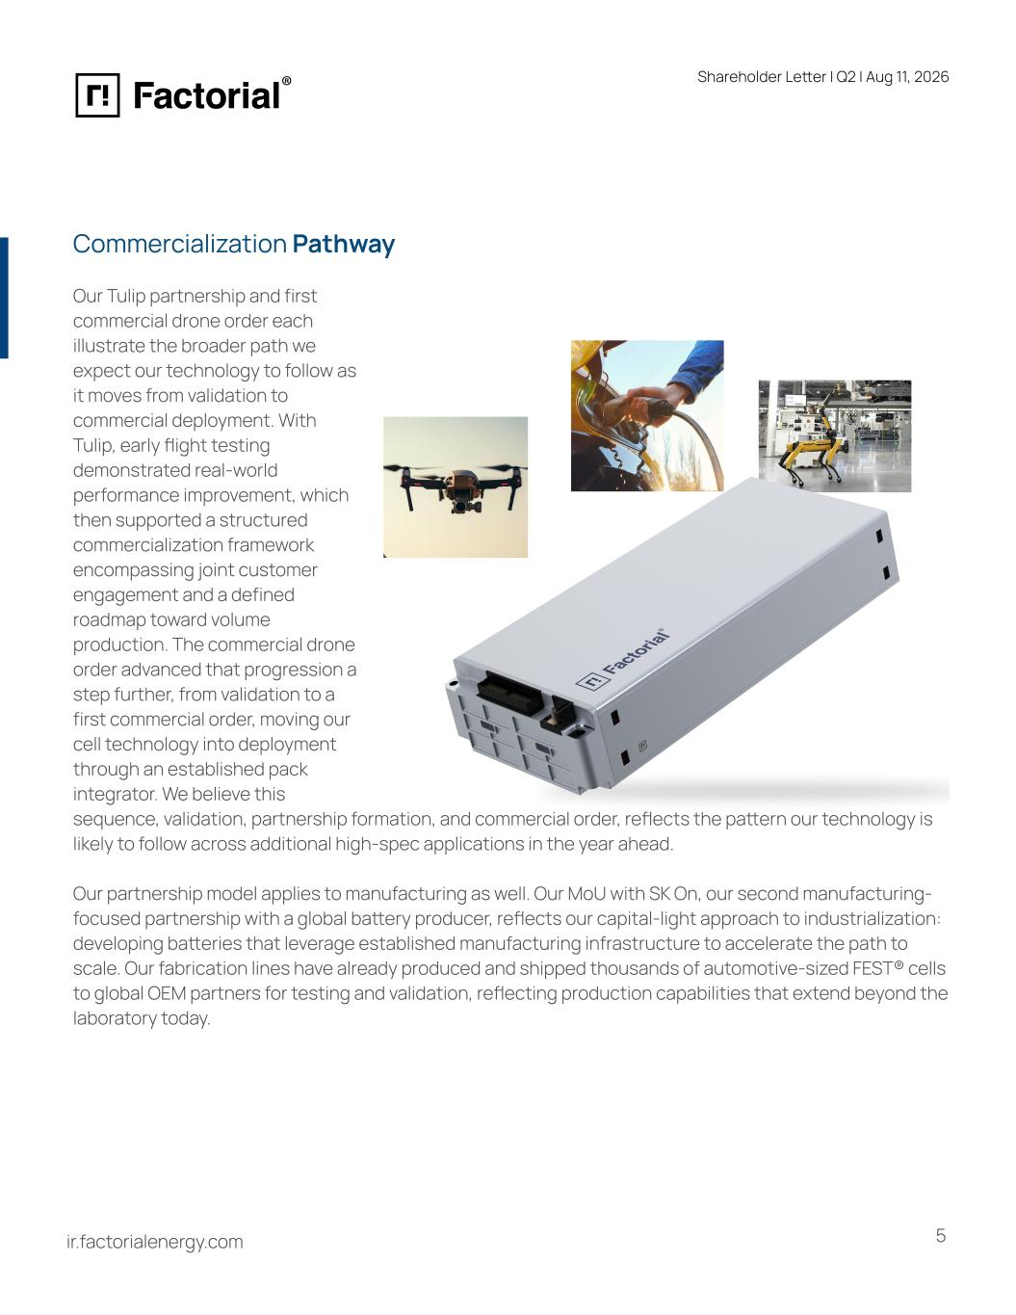
Shareholder Letter I Q2 | Aug 11, 2026 Our Tulip partnership and first commercial drone order each illustrate the broader path we expect our technology to follow as it moves from validation to commercial deployment. With Tulip, early flight testing demonstrated real-world performance improvement, which then supported a structured commercialization framework encompassing joint customer engagement and a defined roadmap toward volume production. The commercial drone order advanced that progression a step further, from validation to a first commercial order, moving our cell technology into deployment through an established pack integrator. We believe this Commercialization Pathway sequence, validation, partnership formation, and commercial order, reflects the pattern our technology is likely to follow across additional high-spec applications in the year ahead. Our partnership model applies to manufacturing as well. Our MoU with SK On, our second manufacturing- focused partnership with a global battery producer, reflects our capital-light approach to industrialization: developing batteries that leverage established manufacturing infrastructure to accelerate the path to scale. Our fabrication lines have already produced and shipped thousands of automotive-sized FEST® cells to global OEM partners for testing and validation, reflecting production capabilities that extend beyond the laboratory today. 5ir.factorialenergy.com

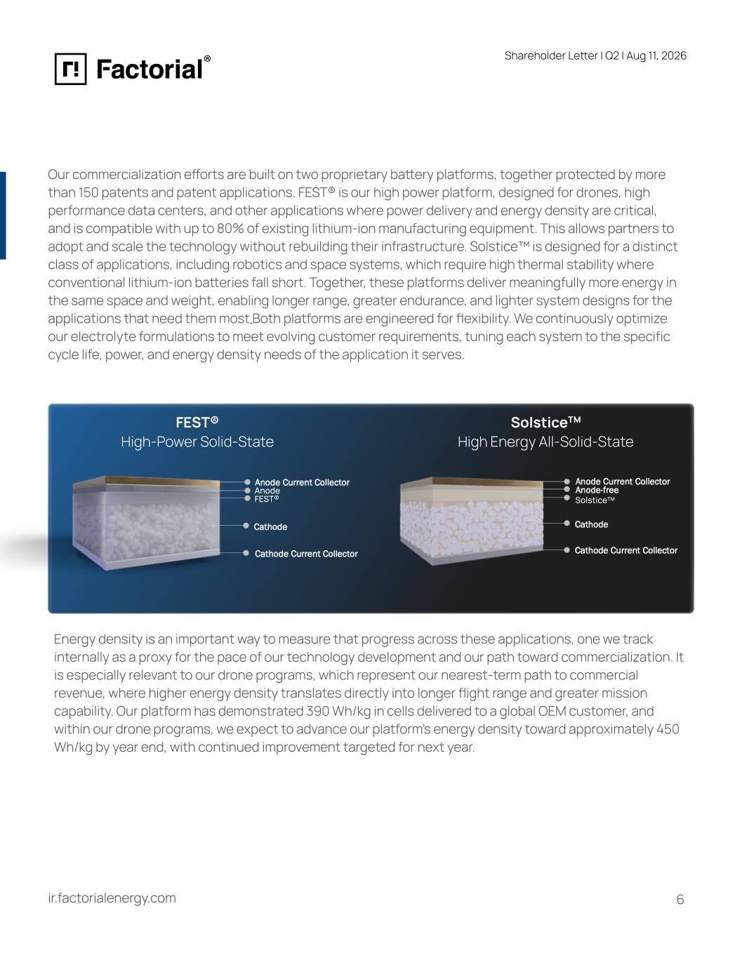
Shareholder Letter I Q2 | Aug 11, 2026 Our commercialization efforts are built on two proprietary battery platforms, together protected by more than 150 patents and patent applications. FEST® is our high power platform, designed for drones, high performance data centers, and other applications where power delivery and energy density are critical, and is compatible with up to 80% of existing lithium-ion manufacturing equipment. This allows partners to adopt and scale the technology without rebuilding their infrastructure. Solstice™ is designed for a distinct class of applications, including robotics and space systems, which require high thermal stability where conventional lithium-ion batteries fall short. Together, these platforms deliver meaningfully more energy in the same space and weight, enabling longer range, greater endurance, and lighter system designs for the applications that need them most Both platforms are engineered for flexibility. We continuously optimize our electrolyte formulations to meet evolving customer requirements, tuning each system to the specific cycle life, power, and energy density needs of the application it serves. FEST® High-Power Solid-State Anode FEST® SolsticeTM High Energy All-Solid-State SolsticeTM Energy density is an important way to measure that progress across these applications, one we track internally as a proxy for the pace of our technology development and our path toward commercialization. It is especially relevant to our drone programs, which represent our nearest-term path to commercial revenue, where higher energy density translates directly into longer flight range and greater mission capability. Our platform has demonstrated 390 Wh/kg in cells delivered to a global OEM customer, and within our drone programs, we expect to advance our platform’s energy density toward approximately 450 Wh/kg by year end, with continued improvement targeted for next year. ir.factorialenergy.com 6 .

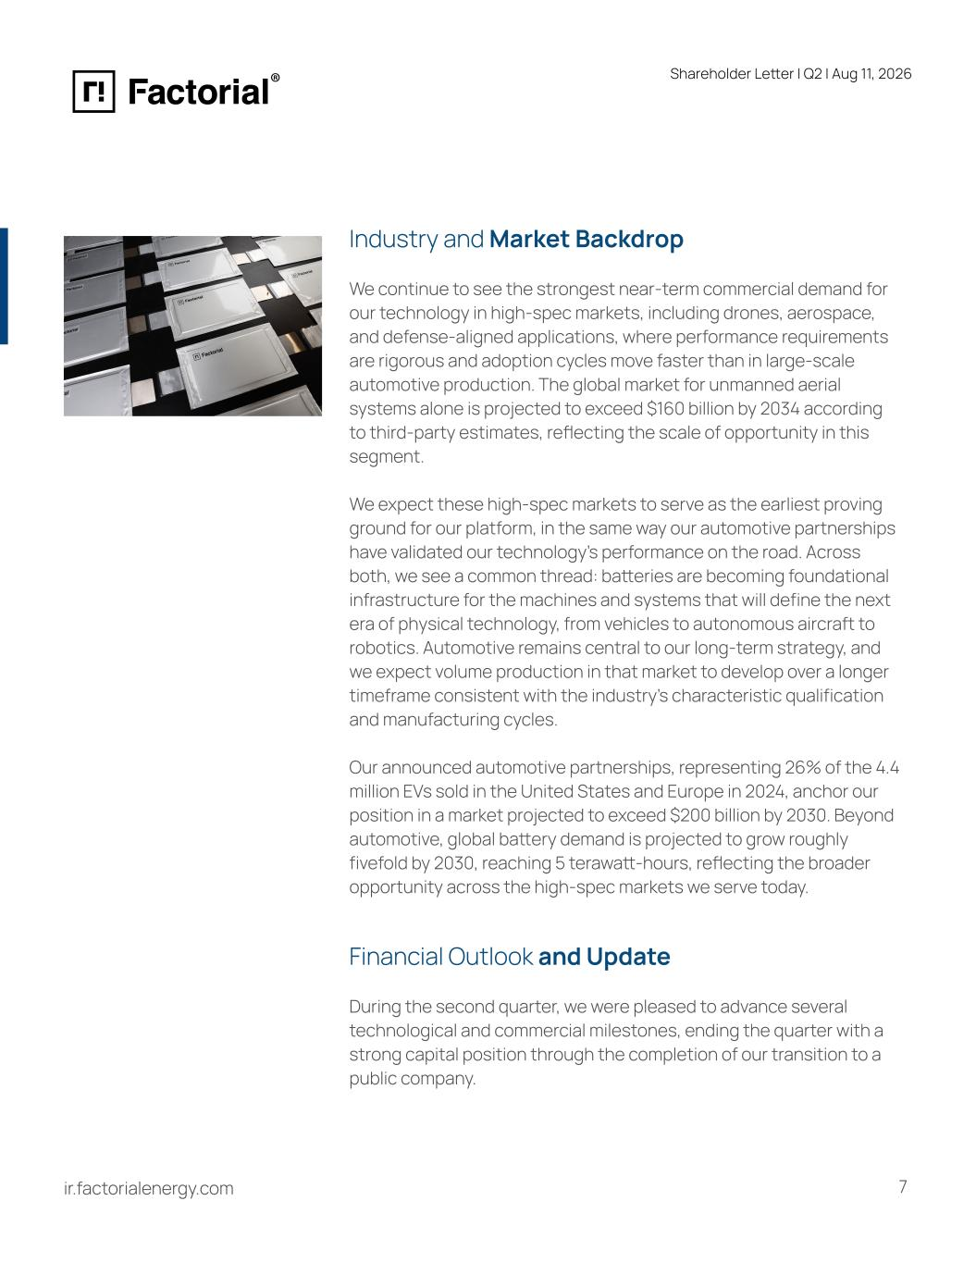
Shareholder Letter I Q2 | Aug 11, 2026 ir.factorialenergy.com Industry and Market Backdrop We continue to see the strongest near-term commercial demand for our technology in high-spec markets, including drones, aerospace, and defense-aligned applications, where performance requirements are rigorous and adoption cycles move faster than in large-scale automotive production. The global market for unmanned aerial systems alone is projected to exceed $160 billion by 2034 according to third-party estimates, reflecting the scale of opportunity in this segment. We expect these high-spec markets to serve as the earliest proving ground for our platform, in the same way our automotive partnerships have validated our technology's performance on the road. Across both, we see a common thread: batteries are becoming foundational infrastructure for the machines and systems that will define the next era of physical technology, from vehicles to autonomous aircraft to robotics. Automotive remains central to our long-term strategy, and we expect volume production in that market to develop over a longer timeframe consistent with the industry's characteristic qualification and manufacturing cycles. Our announced automotive partnerships, representing 26% of the 4.4 million EVs sold in the United States and Europe in 2024, anchor our position in a market projected to exceed $200 billion by 2030. Beyond automotive, global battery demand is projected to grow roughly fivefold by 2030, reaching 5 terawatt-hours, reflecting the broader opportunity across the high-spec markets we serve today. Financial Outlook and Update During the second quarter, we were pleased to advance several technological and commercial milestones, ending the quarter with a strong capital position through the completion of our transition to a public company. 7

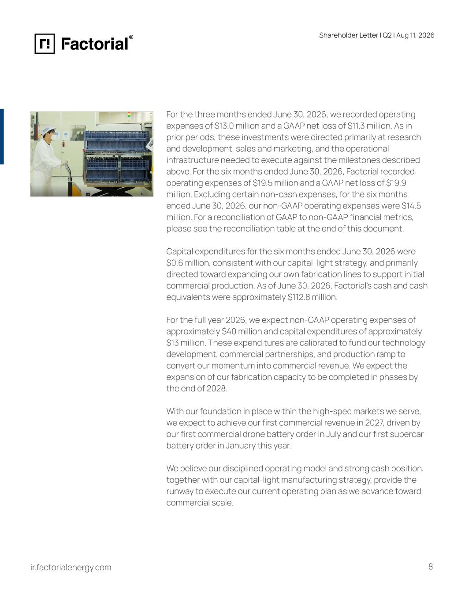
Shareholder Letter I Q2 | Aug 11, 2026 ir.factorialenergy.com For the three months ended June 30, 2026, we recorded operating expenses of $13.0 million and a GAAP net loss of $11.3 million. As in prior periods, these investments were directed primarily at research and development, sales and marketing, and the operational infrastructure needed to execute against the milestones described above. For the six months ended June 30, 2026, Factorial recorded operating expenses of $19.5 million and a GAAP net loss of $19.9 million. Excluding certain non-cash expenses, for the six months ended June 30, 2026, our non-GAAP operating expenses were $14.5 million. For a reconciliation of GAAP to non-GAAP financial metrics, please see the reconciliation table at the end of this document. Capital expenditures for the six months ended June 30, 2026 were $0.6 million, consistent with our capital-light strategy, and primarily directed toward expanding our own fabrication lines to support initial commercial production. As of June 30, 2026, Factorial's cash and cash equivalents were approximately $112.8 million. For the full year 2026, we expect non-GAAP operating expenses of approximately $40 million and capital expenditures of approximately $13 million. These expenditures are calibrated to fund our technology development, commercial partnerships, and production ramp to convert our momentum into commercial revenue. We expect the expansion of our fabrication capacity to be completed in phases by the end of 2028. With our foundation in place within the high-spec markets we serve, we expect to achieve our first commercial revenue in 2027, driven by our first commercial drone battery order in July and our first supercar battery order in January this year. We believe our disciplined operating model and strong cash position, together with our capital-light manufacturing strategy, provide the runway to execute our current operating plan as we advance toward commercial scale. 8

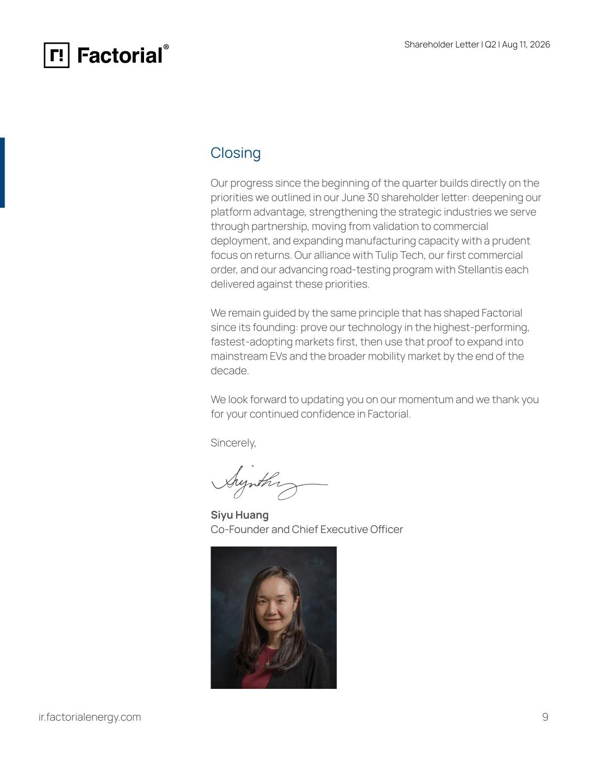
Shareholder Letter I Q2 | Aug 11, 2026 Closing Our progress since the beginning of the quarter builds directly on the priorities we outlined in our June 30 shareholder letter: deepening our platform advantage, strengthening the strategic industries we serve through partnership, moving from validation to commercial deployment, and expanding manufacturing capacity with a prudent focus on returns. Our alliance with Tulip Tech, our first commercial order, and our advancing road-testing program with Stellantis each delivered against these priorities. We remain guided by the same principle that has shaped Factorial since its founding: prove our technology in the highest-performing, fastest-adopting markets first, then use that proof to expand into mainstream EVs and the broader mobility market by the end of the decade. We look forward to updating you on our momentum and we thank you for your continued confidence in Factorial. Sincerely, Siyu Huang Co-Founder and Chief Executive Officer ir.factorialenergy.com 9

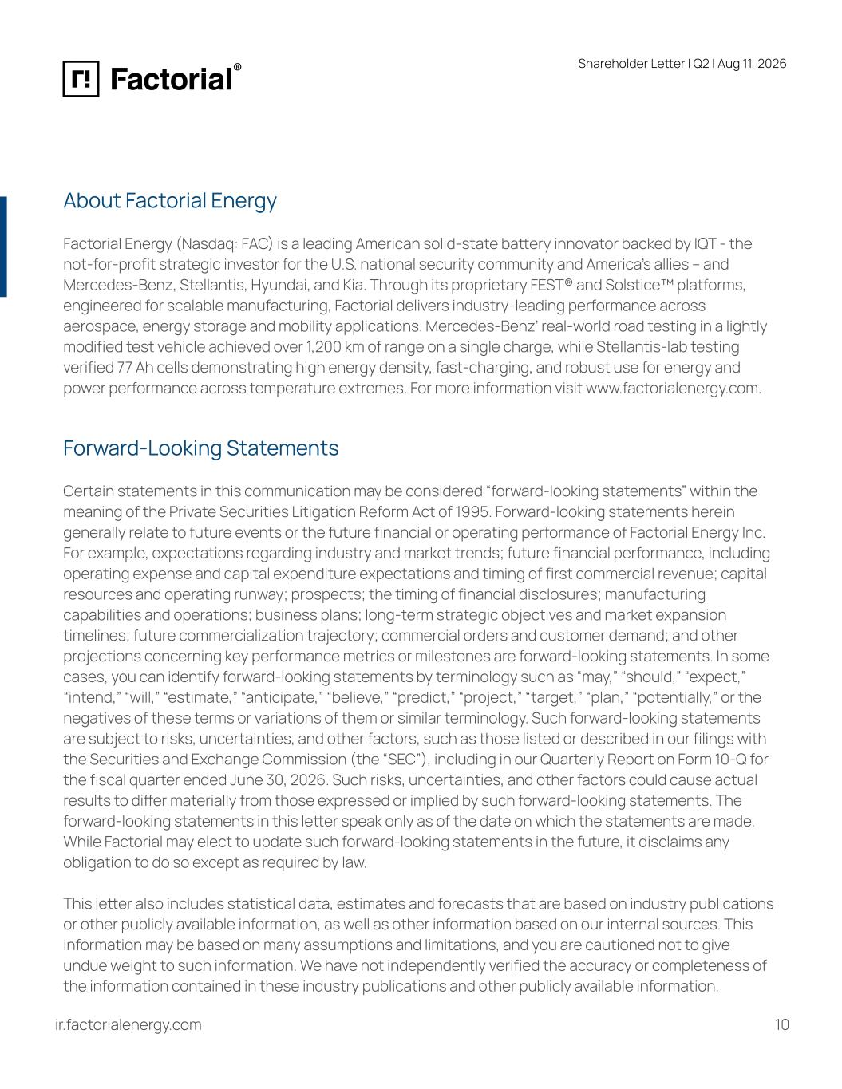
Shareholder Letter I Q2 | Aug 11, 2026 About Factorial Energy Factorial Energy (Nasdaq: FAC) is a leading American solid-state battery innovator backed by IQT - the not-for-profit strategic investor for the U.S. national security community and America’s allies – and Mercedes-Benz, Stellantis, Hyundai, and Kia. Through its proprietary FEST® and Solstice™ platforms, engineered for scalable manufacturing, Factorial delivers industry-leading performance across aerospace, energy storage and mobility applications. Mercedes-Benz’ real-world road testing in a lightly modified test vehicle achieved over 1,200 km of range on a single charge, while Stellantis-lab testing verified 77 Ah cells demonstrating high energy density, fast-charging, and robust use for energy and power performance across temperature extremes. For more information visit www.factorialenergy.com. Forward-Looking Statements Certain statements in this communication may be considered “forward-looking statements” within the meaning of the Private Securities Litigation Reform Act of 1995. Forward-looking statements herein generally relate to future events or the future financial or operating performance of Factorial Energy Inc. For example, expectations regarding industry and market trends; future financial performance, including operating expense and capital expenditure expectations and timing of first commercial revenue; capital resources and operating runway; prospects; the timing of financial disclosures; manufacturing capabilities and operations; business plans; long-term strategic objectives and market expansion timelines; future commercialization trajectory; commercial orders and customer demand; and other projections concerning key performance metrics or milestones are forward-looking statements. In some cases, you can identify forward-looking statements by terminology such as “may,” “should,” “expect,” “intend,” “will,” “estimate,” “anticipate,” “believe,” “predict,” “project,” “target,” “plan,” “potentially,” or the negatives of these terms or variations of them or similar terminology. Such forward-looking statements are subject to risks, uncertainties, and other factors, such as those listed or described in our filings with the Securities and Exchange Commission (the “SEC”), including in our Quarterly Report on Form 10-Q for the fiscal quarter ended June 30, 2026. Such risks, uncertainties, and other factors could cause actual results to differ materially from those expressed or implied by such forward-looking statements. The forward-looking statements in this letter speak only as of the date on which the statements are made. While Factorial may elect to update such forward-looking statements in the future, it disclaims any obligation to do so except as required by law. This letter also includes statistical data, estimates and forecasts that are based on industry publications or other publicly available information, as well as other information based on our internal sources. This information may be based on many assumptions and limitations, and you are cautioned not to give undue weight to such information. We have not independently verified the accuracy or completeness of the information contained in these industry publications and other publicly available information. ir.factorialenergy.com 10

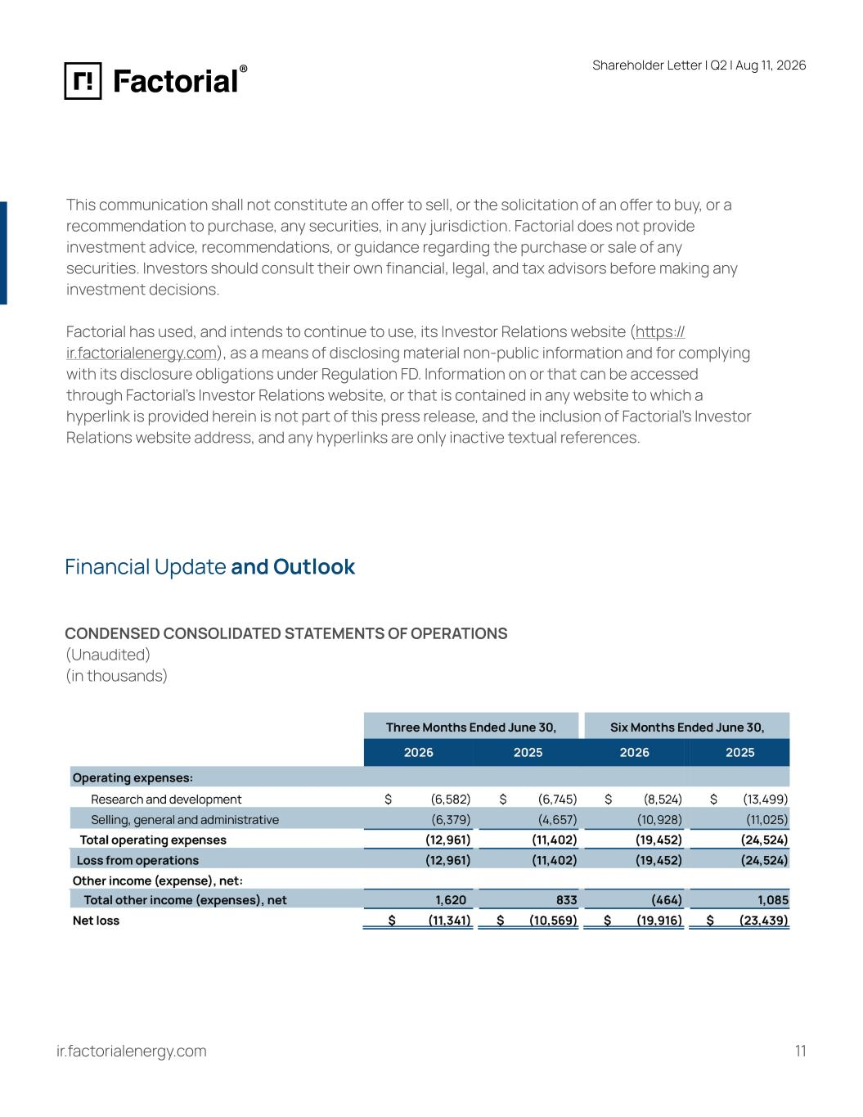
Shareholder Letter I Q2 | Aug 11, 2026 This communication shall not constitute an offer to sell, or the solicitation of an offer to buy, or a recommendation to purchase, any securities, in any jurisdiction. Factorial does not provide investment advice, recommendations, or guidance regarding the purchase or sale of any securities. Investors should consult their own financial, legal, and tax advisors before making any investment decisions. Factorial has used, and intends to continue to use, its Investor Relations website (https:// ir.factorialenergy.com), as a means of disclosing material non-public information and for complying with its disclosure obligations under Regulation FD. Information on or that can be accessed through Factorial’s Investor Relations website, or that is contained in any website to which a hyperlink is provided herein is not part of this press release, and the inclusion of Factorial’s Investor Relations website address, and any hyperlinks are only inactive textual references. Financial Update and Outlook CONDENSED CONSOLIDATED STATEMENTS OF OPERATIONS (Unaudited) (in thousands) ir.factorialenergy.com 11

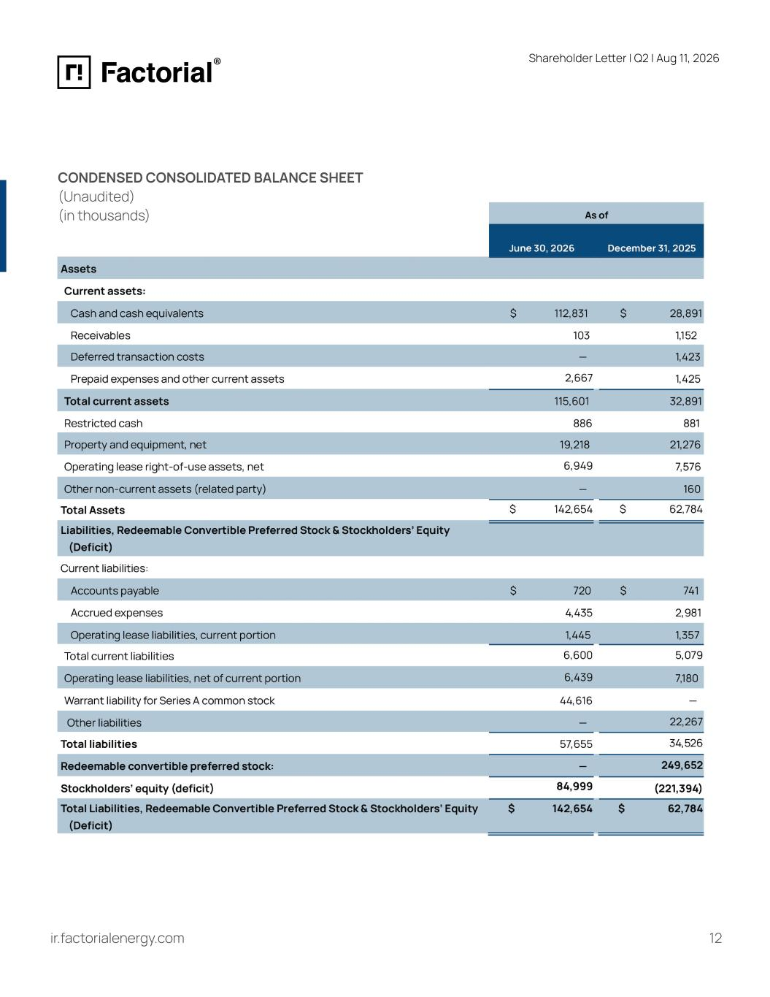
Shareholder Letter I Q2 | Aug 11, 2026 CONDENSED CONSOLIDATED BALANCE SHEET (Unaudited) (in thousands) ir.factorialenergy.com 12

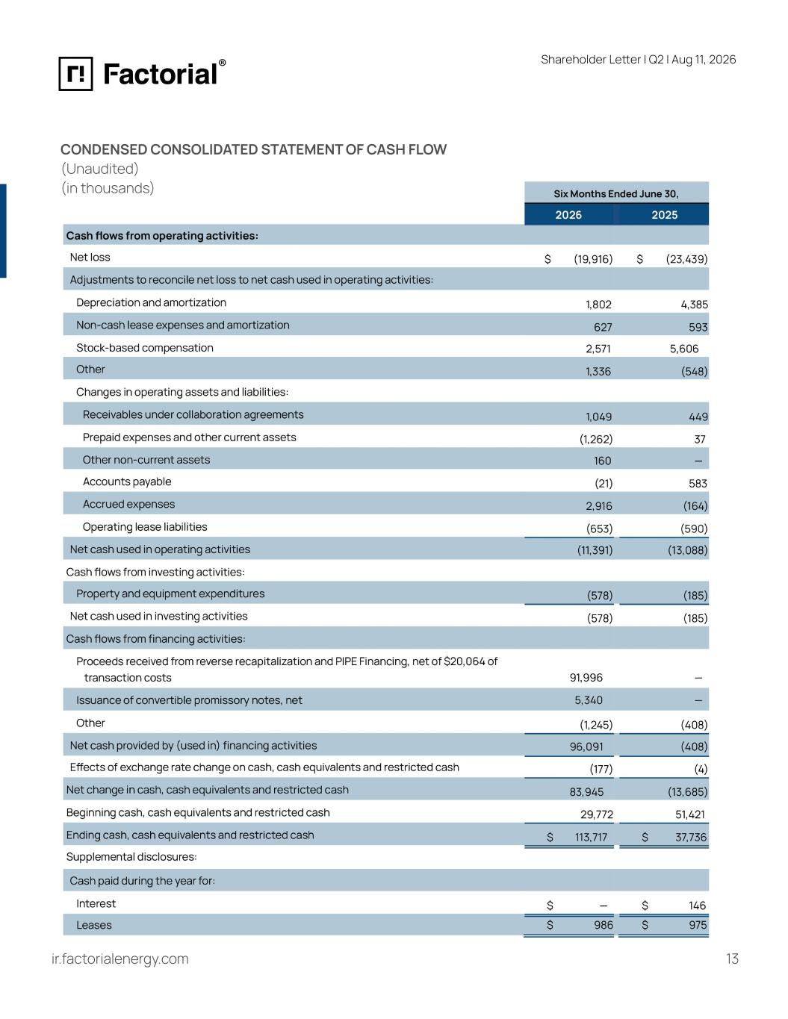
Shareholder Letter I Q2 | Aug 11, 2026 CONDENSED CONSOLIDATED STATEMENT OF CASH FLOW (Unaudited) (in thousands) ir.factorialenergy.com 13

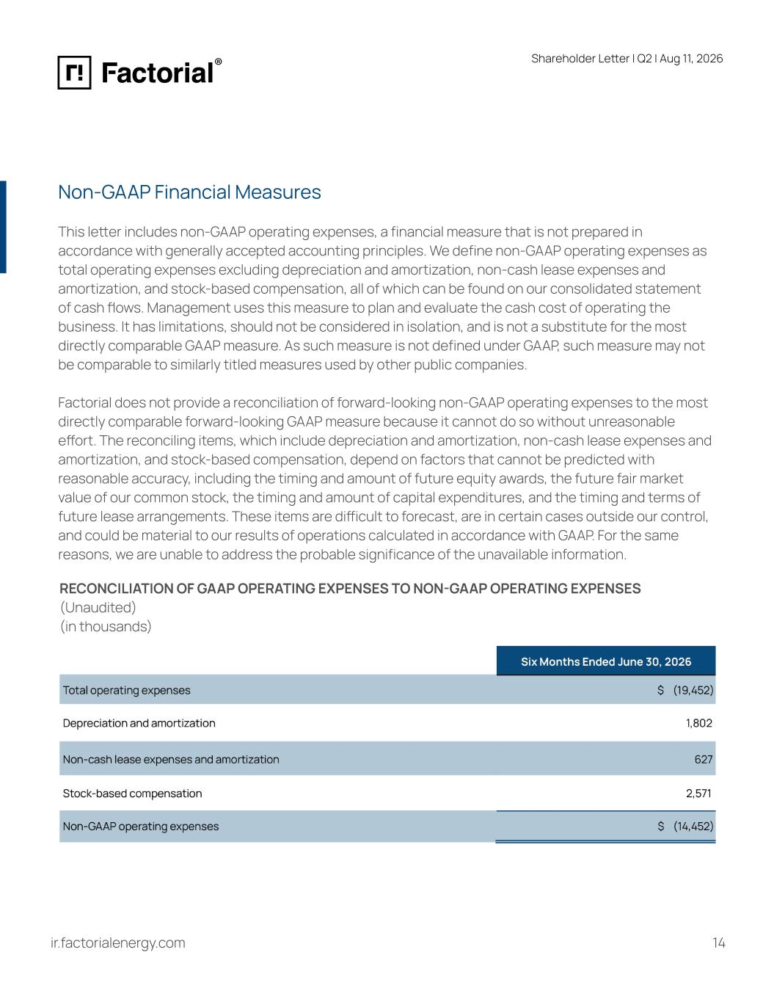
Shareholder Letter I Q2 | Aug 11, 2026 Non-GAAP Financial Measures This letter includes non-GAAP operating expenses, a financial measure that is not prepared in accordance with generally accepted accounting principles. We define non-GAAP operating expenses as total operating expenses excluding depreciation and amortization, non-cash lease expenses and amortization, and stock-based compensation, all of which can be found on our consolidated statement of cash flows. Management uses this measure to plan and evaluate the cash cost of operating the business. It has limitations, should not be considered in isolation, and is not a substitute for the most directly comparable GAAP measure. As such measure is not defined under GAAP, such measure may not be comparable to similarly titled measures used by other public companies. Factorial does not provide a reconciliation of forward-looking non-GAAP operating expenses to the most directly comparable forward-looking GAAP measure because it cannot do so without unreasonable effort. The reconciling items, which include depreciation and amortization, non-cash lease expenses and amortization, and stock-based compensation, depend on factors that cannot be predicted with reasonable accuracy, including the timing and amount of future equity awards, the future fair market value of our common stock, the timing and amount of capital expenditures, and the timing and terms of future lease arrangements. These items are difficult to forecast, are in certain cases outside our control, and could be material to our results of operations calculated in accordance with GAAP. For the same reasons, we are unable to address the probable significance of the unavailable information. RECONCILIATION OF GAAP OPERATING EXPENSES TO NON-GAAP OPERATING EXPENSES (Unaudited) (in thousands) ir.factorialenergy.com 14

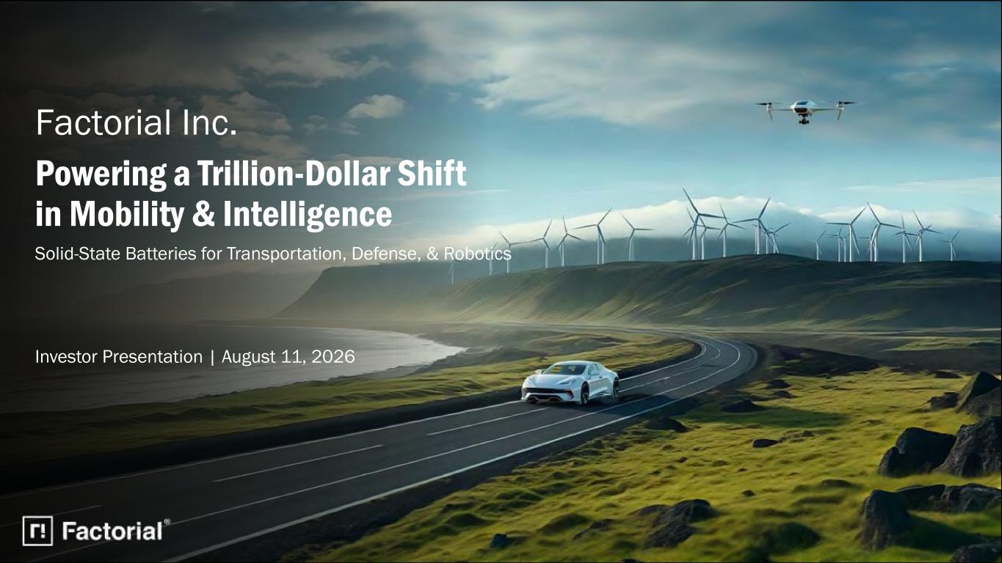
Powering a Trillion-Dollar Shift in Mobility & Intelligence Factorial Inc. Solid-State Batteries for Transportation, Defense, & Robotics Investor Presentation | August 11, 2026

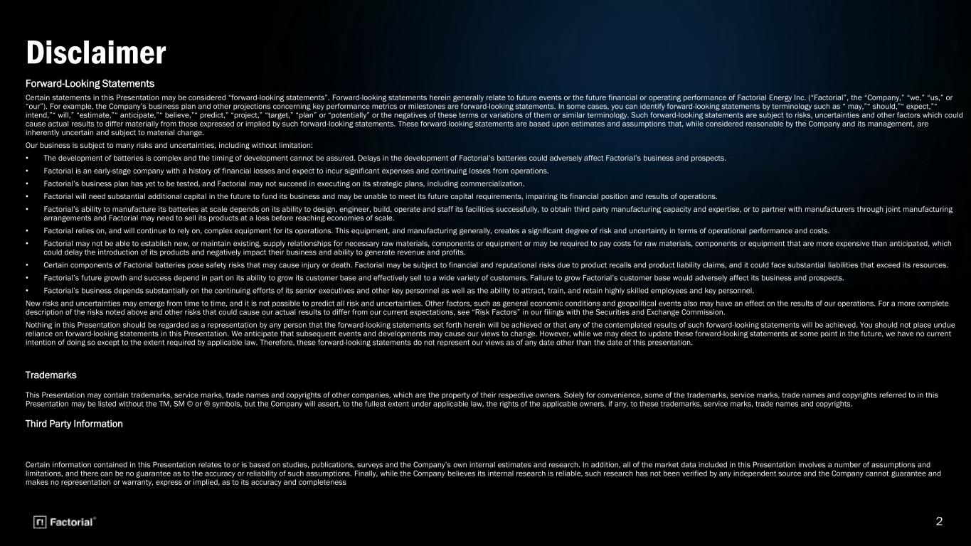
2 Forward-Looking Statements Certain statements in this Presentation may be considered “forward-looking statements”. Forward-looking statements herein generally relate to future events or the future financial or operating performance of Factorial Energy Inc. (“Factorial”, the “Company,” “we,” “us,” or “our”). For example, the Company’s business plan and other projections concerning key performance metrics or milestones are forward-looking statements. In some cases, you can identify forward-looking statements by terminology such as “ may,”“ should,”“ expect,”“ intend,”“ will,” “estimate,”“ anticipate,”“ believe,”“ predict,” “project,” “target,” “plan” or “potentially” or the negatives of these terms or variations of them or similar terminology. Such forward-looking statements are subject to risks, uncertainties and other factors which could cause actual results to differ materially from those expressed or implied by such forward-looking statements. These forward-looking statements are based upon estimates and assumptions that, while considered reasonable by the Company and its management, are inherently uncertain and subject to material change. Our business is subject to many risks and uncertainties, including without limitation: • The development of batteries is complex and the timing of development cannot be assured. Delays in the development of Factorial’s batteries could adversely affect Factorial’s business and prospects. • Factorial is an early-stage company with a history of financial losses and expect to incur significant expenses and continuing losses from operations. • Factorial’s business plan has yet to be tested, and Factorial may not succeed in executing on its strategic plans, including commercialization. • Factorial will need substantial additional capital in the future to fund its business and may be unable to meet its future capital requirements, impairing its financial position and results of operations. • Factorial’s ability to manufacture its batteries at scale depends on its ability to design, engineer, build, operate and staff its facilities successfully, to obtain third party manufacturing capacity and expertise, or to partner with manufacturers through joint manufacturing arrangements and Factorial may need to sell its products at a loss before reaching economies of scale. • Factorial relies on, and will continue to rely on, complex equipment for its operations. This equipment, and manufacturing generally, creates a significant degree of risk and uncertainty in terms of operational performance and costs. • Factorial may not be able to establish new, or maintain existing, supply relationships for necessary raw materials, components or equipment or may be required to pay costs for raw materials, components or equipment that are more expensive than anticipated, which could delay the introduction of its products and negatively impact their business and ability to generate revenue and profits. • Certain components of Factorial batteries pose safety risks that may cause injury or death. Factorial may be subject to financial and reputational risks due to product recalls and product liability claims, and it could face substantial liabilities that exceed its resources. • Factorial’s future growth and success depend in part on its ability to grow its customer base and effectively sell to a wide variety of customers. Failure to grow Factorial’s customer base would adversely affect its business and prospects. • Factorial’s business depends substantially on the continuing efforts of its senior executives and other key personnel as well as the ability to attract, train, and retain highly skilled employees and key personnel. New risks and uncertainties may emerge from time to time, and it is not possible to predict all risk and uncertainties. Other factors, such as general economic conditions and geopolitical events also may have an effect on the results of our operations. For a more complete description of the risks noted above and other risks that could cause our actual results to differ from our current expectations, see “Risk Factors” in our filings with the Securities and Exchange Commission. Nothing in this Presentation should be regarded as a representation by any person that the forward-looking statements set forth herein will be achieved or that any of the contemplated results of such forward-looking statements will be achieved. You should not place undue reliance on forward-looking statements in this Presentation. We anticipate that subsequent events and developments may cause our views to change. However, while we may elect to update these forward-looking statements at some point in the future, we have no current intention of doing so except to the extent required by applicable law. Therefore, these forward-looking statements do not represent our views as of any date other than the date of this presentation. Trademarks This Presentation may contain trademarks, service marks, trade names and copyrights of other companies, which are the property of their respective owners. Solely for convenience, some of the trademarks, service marks, trade names and copyrights referred to in this Presentation may be listed without the TM, SM © or ® symbols, but the Company will assert, to the fullest extent under applicable law, the rights of the applicable owners, if any, to these trademarks, service marks, trade names and copyrights. Third Party Information Certain information contained in this Presentation relates to or is based on studies, publications, surveys and the Company’s own internal estimates and research. In addition, all of the market data included in this Presentation involves a number of assumptions and limitations, and there can be no guarantee as to the accuracy or reliability of such assumptions. Finally, while the Company believes its internal research is reliable, such research has not been verified by any independent source and the Company cannot guarantee and makes no representation or warranty, express or implied, as to its accuracy and completeness Disclaimer

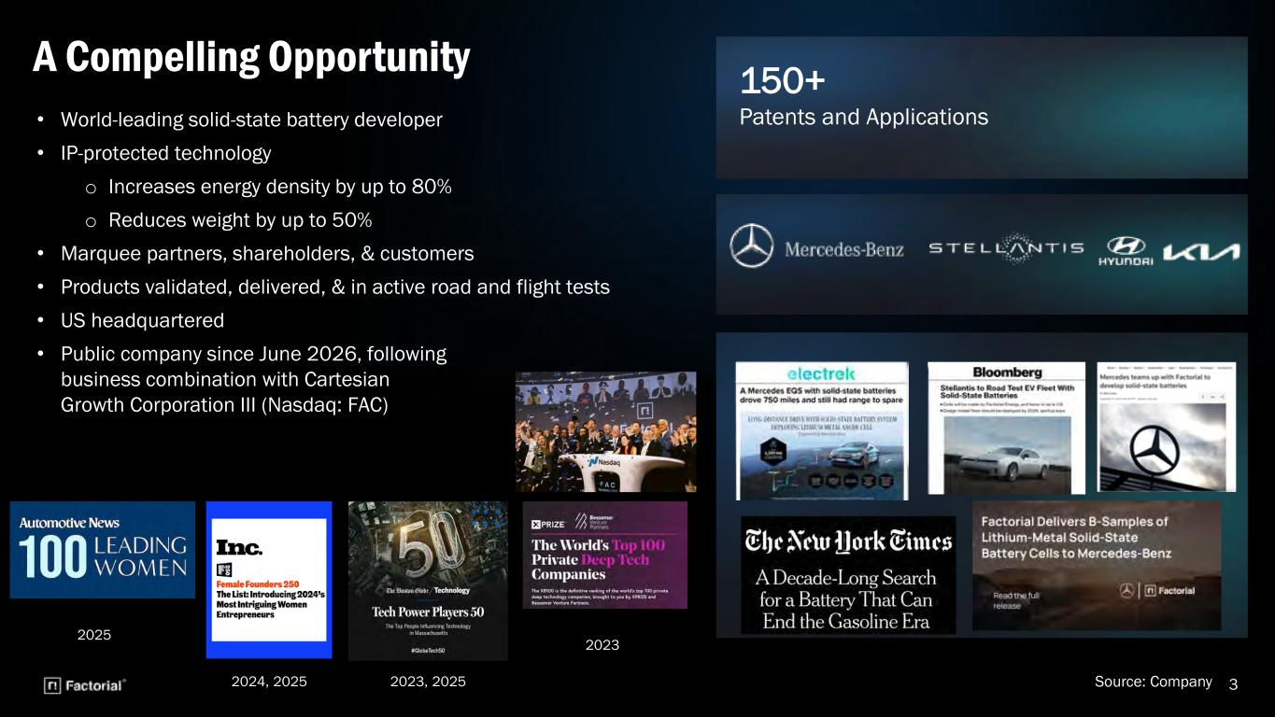
3 • World-leading solid-state battery developer • IP-protected technology o Increases energy density by up to 80% o Reduces weight by up to 50% • Marquee partners, shareholders, & customers • Products validated, delivered, & in active road and flight tests • US headquartered • Public company since June 2026, following business combination with Cartesian Growth Corporation III (Nasdaq: FAC) A Compelling Opportunity 150+ Patents and Applications Source: Company 2023 2023, 20252024, 2025 2025

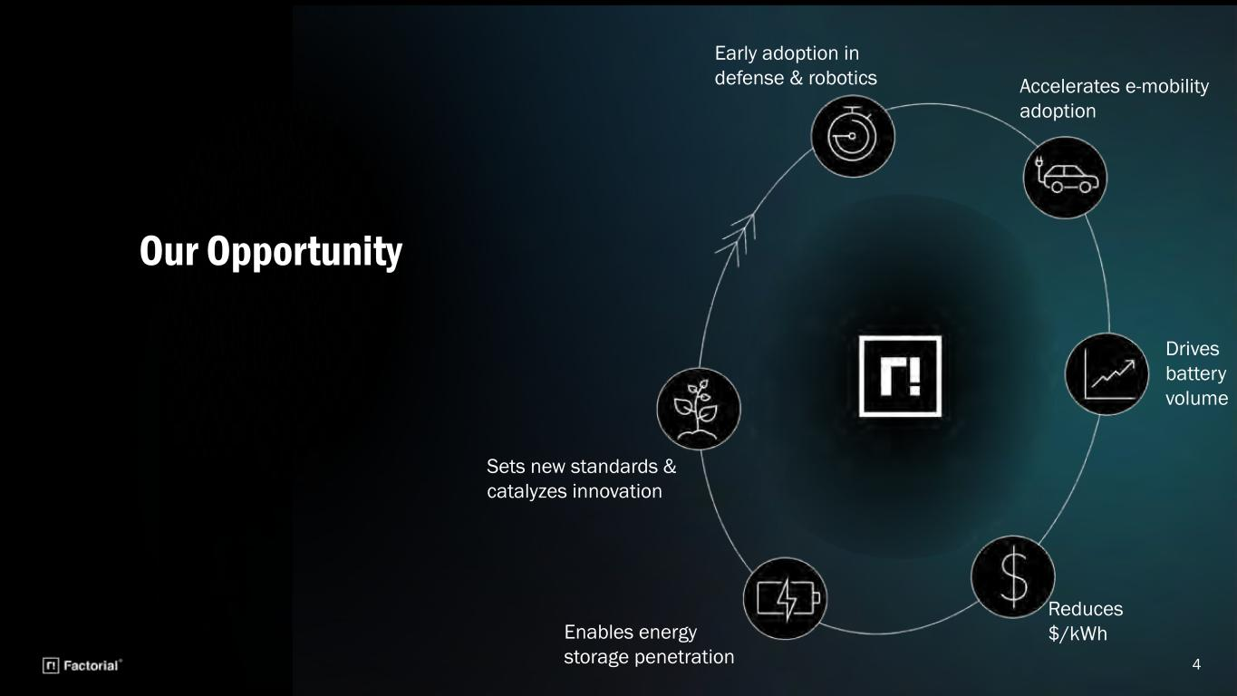
Early adoption in defense & robotics Accelerates e-mobility adoption Sets new standards & catalyzes innovation Enables energy storage penetration Reduces $/kWh Drives battery volume Our Opportunity 4

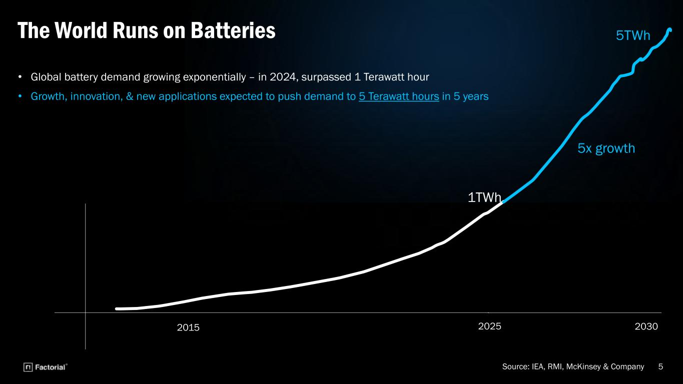
5 The World Runs on Batteries • Global battery demand growing exponentially – in 2024, surpassed 1 Terawatt hour • Growth, innovation, & new applications expected to push demand to 5 Terawatt hours in 5 years 5x growth 2025 2030 1TWh 5TWh 2015 Source: IEA, RMI, McKinsey & Company

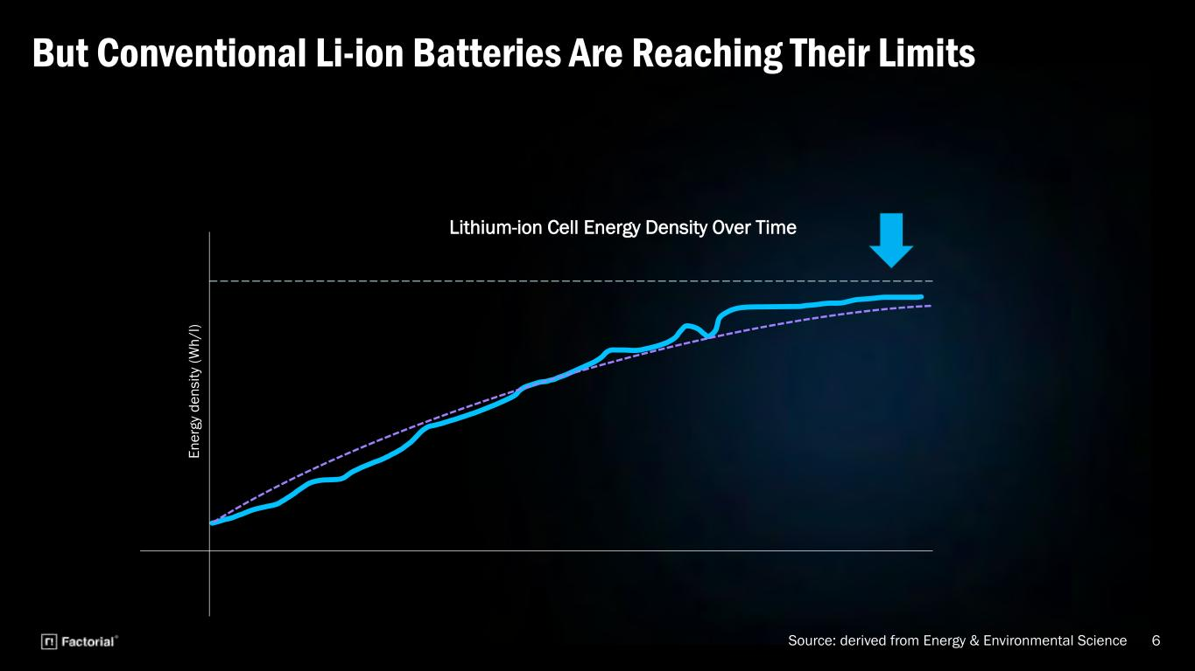
6 But Conventional Li-ion Batteries Are Reaching Their Limits E n e rg y d e n s it y (W h / l) Lithium-ion Cell Energy Density Over Time Source: derived from Energy & Environmental Science

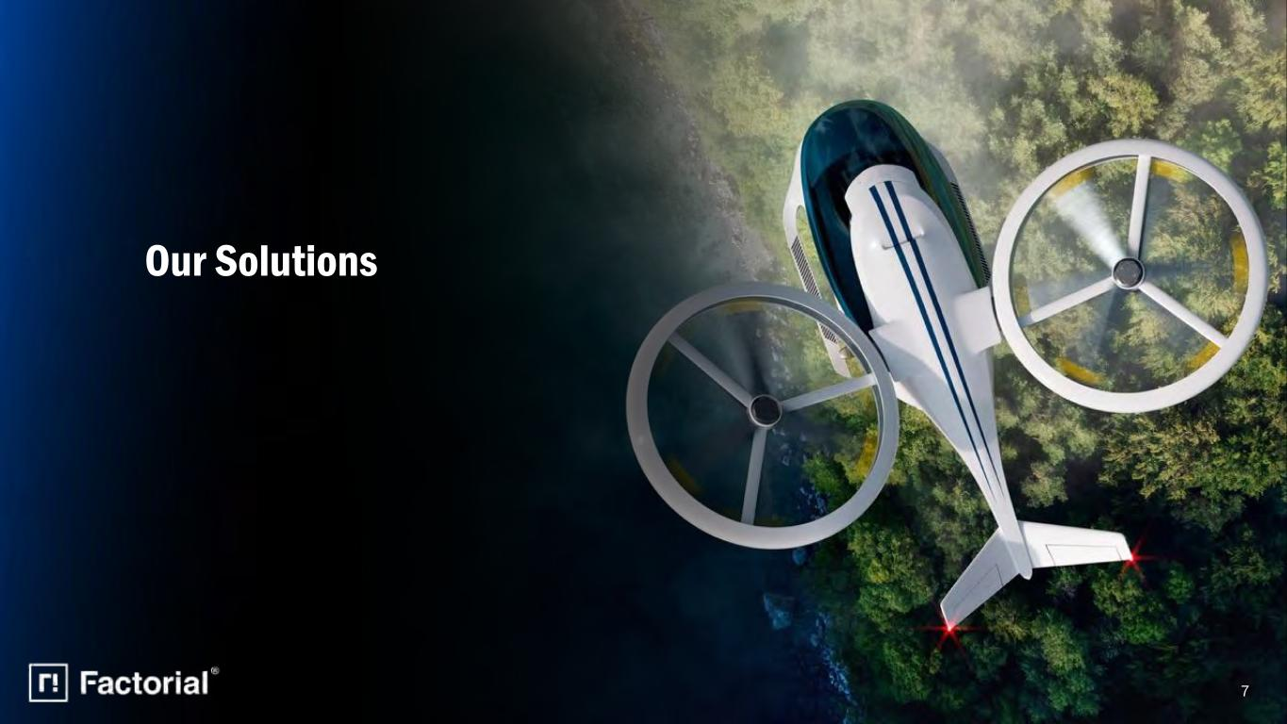
Our Solutions 7

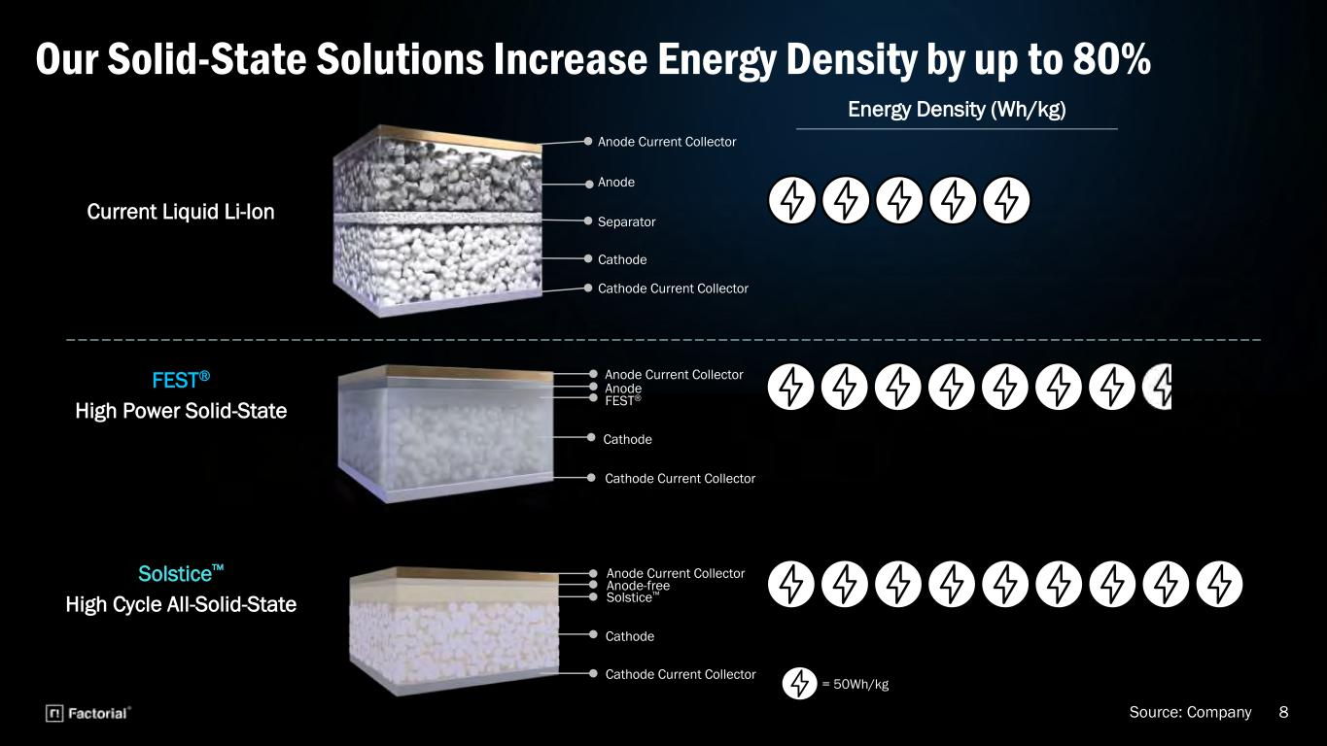
8 Our Solid-State Solutions Increase Energy Density by up to 80% FEST® High Power Solid-State Current Liquid Li-Ion Solstice™ High Cycle All-Solid-State Energy Density (Wh/kg) = 50Wh/kg Anode Current Collector Cathode Cathode Current Collector Separator Anode Anode Current Collector Anode FEST® Cathode Cathode Current Collector Anode Current Collector Solstice™ Cathode Cathode Current Collector Anode-free Source: Company

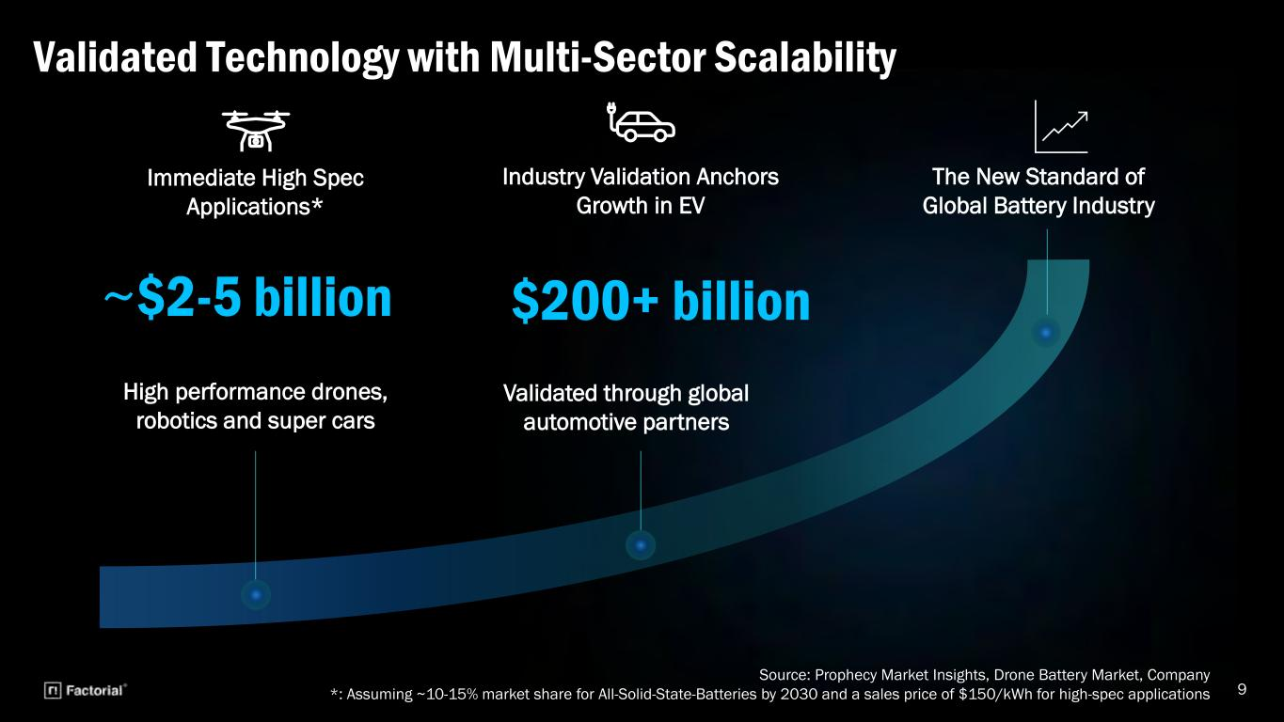
9 Validated Technology with Multi-Sector Scalability Immediate High Spec Applications* ~$2-5 billion Industry Validation Anchors Growth in EV $200+ billion The New Standard of Global Battery Industry Source: Prophecy Market Insights, Drone Battery Market, Company *: Assuming ~10-15% market share for All-Solid-State-Batteries by 2030 and a sales price of $150/kWh for high-spec applications Validated through global automotive partners High performance drones, robotics and super cars

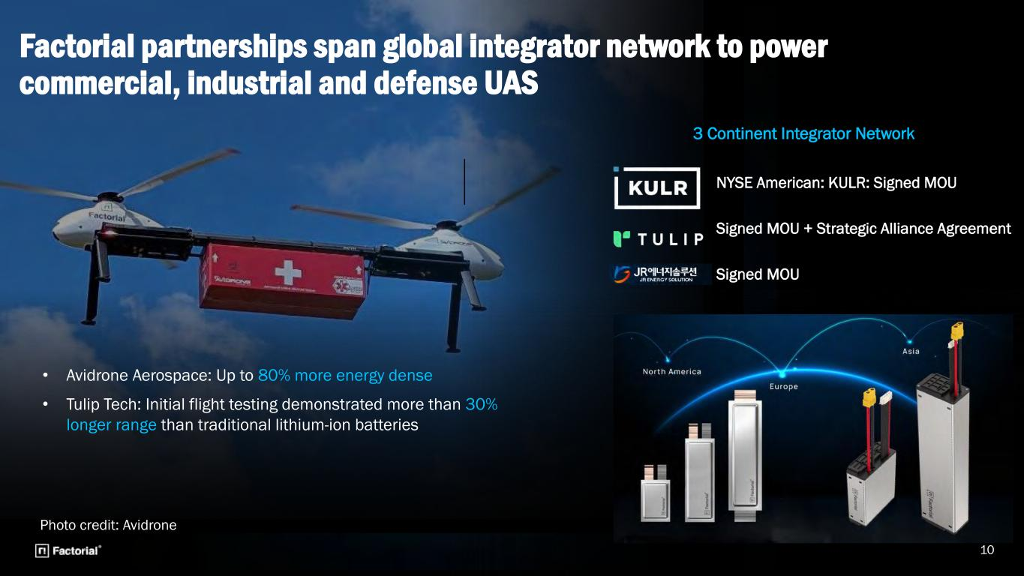
10 NYSE American: KULR: Signed MOU Signed MOU + Strategic Alliance Agreement Signed MOU Photo credit: Avidrone Factorial partnerships span global integrator network to power commercial, industrial and defense UAS • Avidrone Aerospace: Up to 80% more energy dense • Tulip Tech: Initial flight testing demonstrated more than 30% longer range than traditional lithium-ion batteries 3 Continent Integrator Network

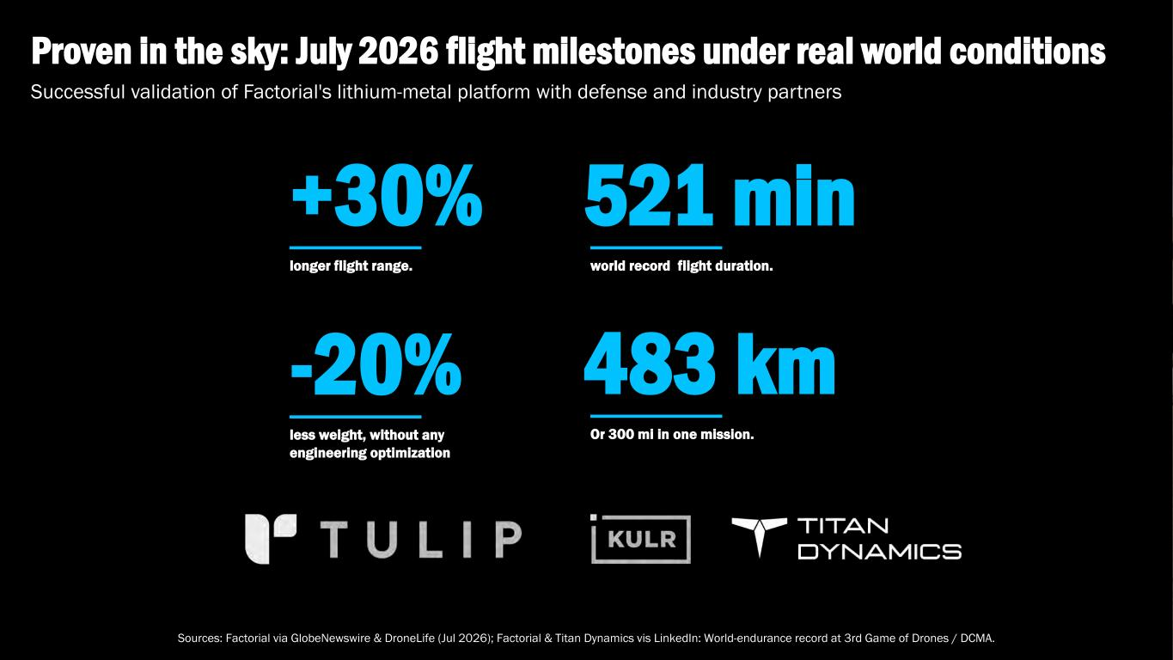
+30% longer flight range. 521 min world record flight duration. Successful validation of Factorial's lithium-metal platform with defense and industry partners Proven in the sky: July 2026 flight milestones under real world conditions Sources: Factorial via GlobeNewswire & DroneLife (Jul 2026); Factorial & Titan Dynamics vis LinkedIn: World-endurance record at 3rd Game of Drones / DCMA. -20% less weight, without any engineering optimization 483 km Or 300 mi in one mission.

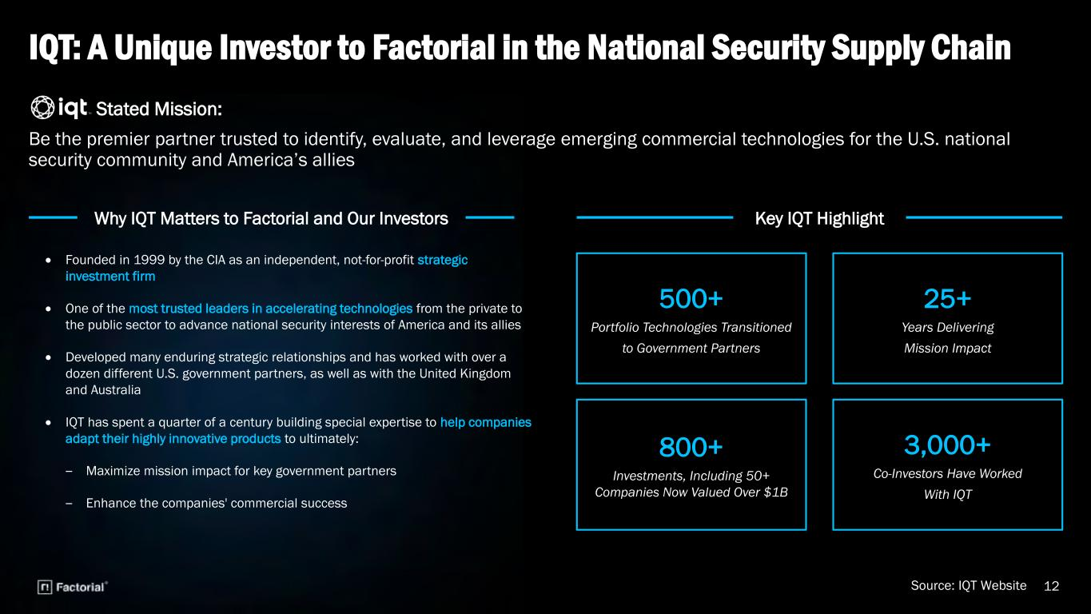
IQT: A Unique Investor to Factorial in the National Security Supply Chain 12 Stated Mission: Be the premier partner trusted to identify, evaluate, and leverage emerging commercial technologies for the U.S. national security community and America’s allies Source: IQT Website • Founded in 1999 by the CIA as an independent, not-for-profit strategic investment firm • One of the most trusted leaders in accelerating technologies from the private to the public sector to advance national security interests of America and its allies • Developed many enduring strategic relationships and has worked with over a dozen different U.S. government partners, as well as with the United Kingdom and Australia • IQT has spent a quarter of a century building special expertise to help companies adapt their highly innovative products to ultimately: ‒ Maximize mission impact for key government partners ‒ Enhance the companies' commercial success 500+ Portfolio Technologies Transitioned to Government Partners 25+ Years Delivering Mission Impact 800+ Investments, Including 50+ Companies Now Valued Over $1B 3,000+ Co-Investors Have Worked With IQT Key IQT HighlightWhy IQT Matters to Factorial and Our Investors

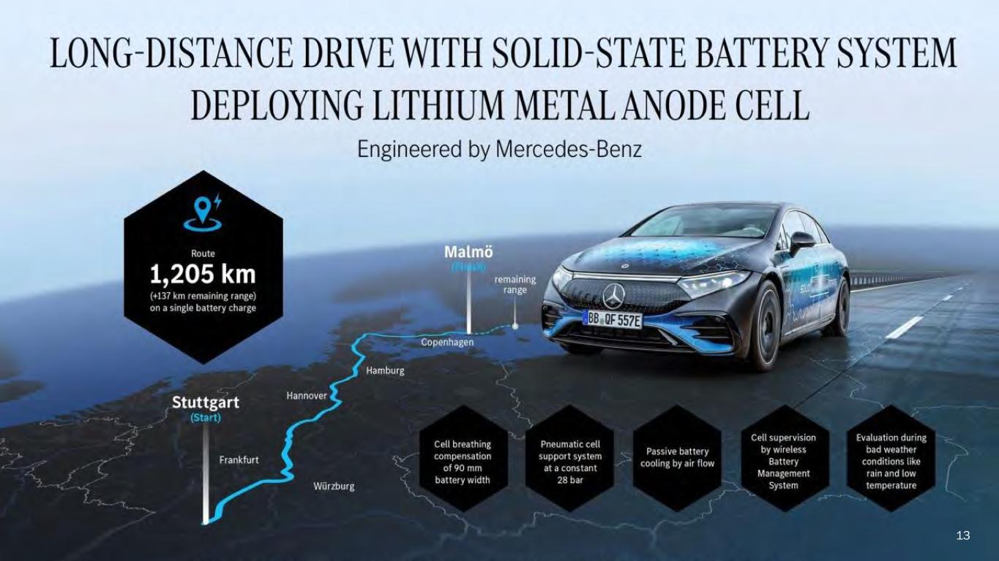
13

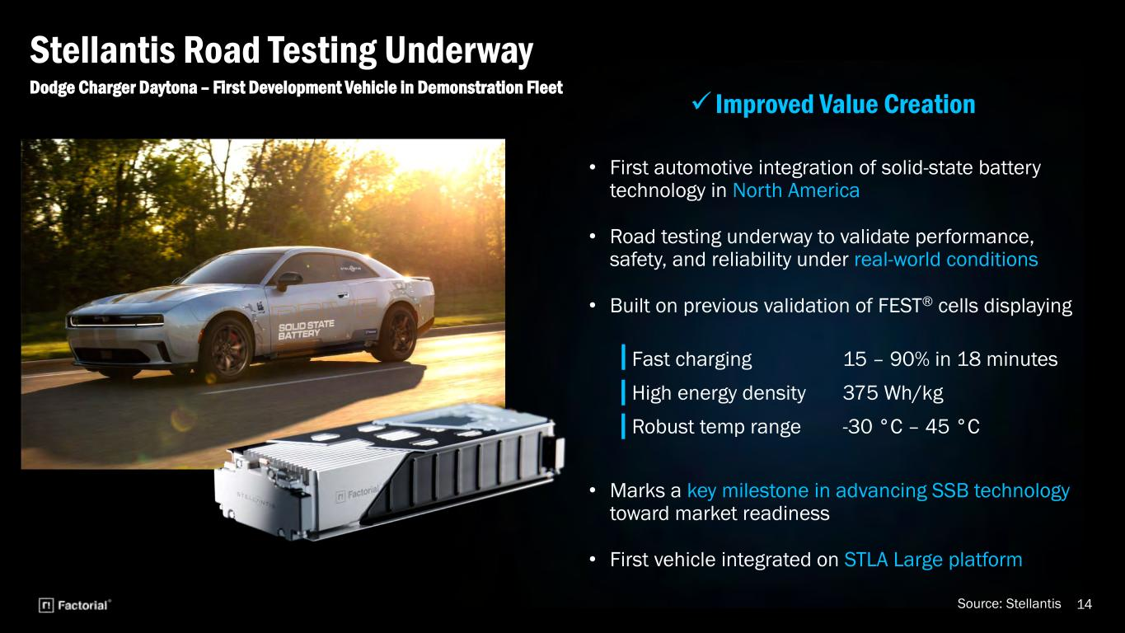
• First automotive integration of solid-state battery technology in North America • Road testing underway to validate performance, safety, and reliability under real-world conditions • Built on previous validation of FEST® cells displaying • Marks a key milestone in advancing SSB technology toward market readiness • First vehicle integrated on STLA Large platform 14 Dodge Charger Daytona – First Development Vehicle in Demonstration Fleet Stellantis Road Testing Underway Source: Stellantis Fast charging 15 – 90% in 18 minutes High energy density 375 Wh/kg Robust temp range -30 °C – 45 °C

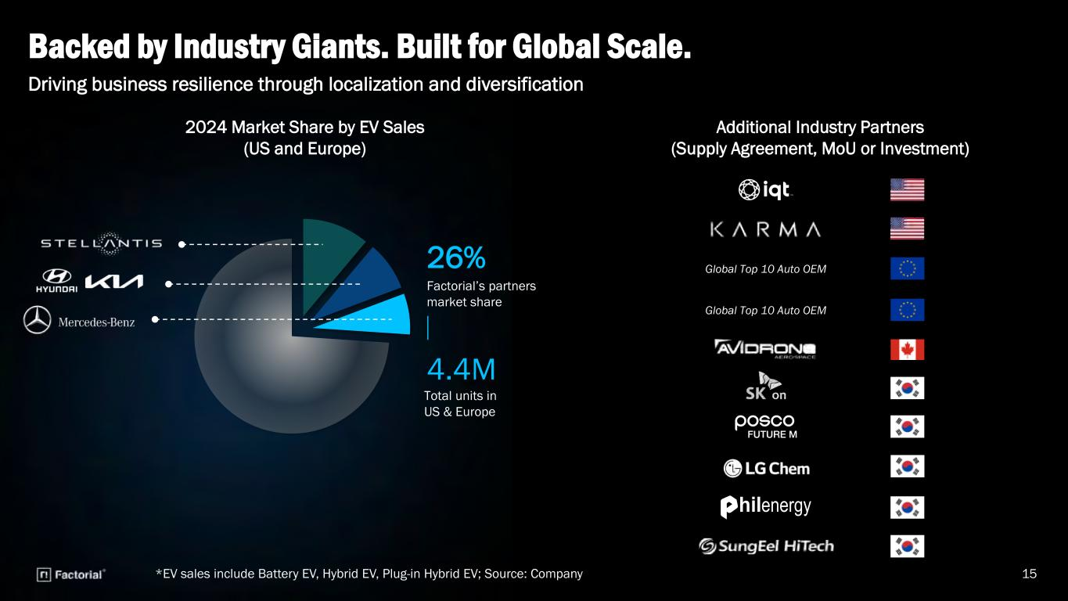
2024 Market Share by EV Sales (US and Europe) Backed by Industry Giants. Built for Global Scale. Additional Industry Partners (Supply Agreement, MoU or Investment) *EV sales include Battery EV, Hybrid EV, Plug-in Hybrid EV; Source: Company 15 Driving business resilience through localization and diversification Factorial’s partners market share 26% Total units in US & Europe 4.4M Global Top 10 Auto OEM Global Top 10 Auto OEM

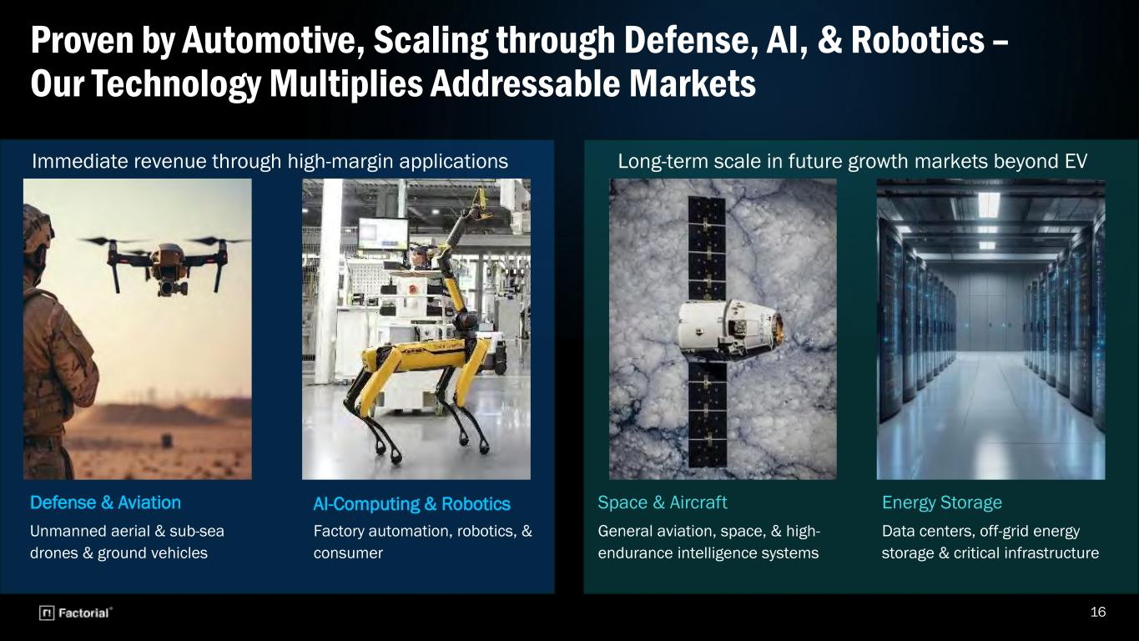
16 Proven by Automotive, Scaling through Defense, AI, & Robotics – Our Technology Multiplies Addressable Markets Defense & Aviation Unmanned aerial & sub-sea drones & ground vehicles AI-Computing & Robotics Factory automation, robotics, & consumer Energy Storage Data centers, off-grid energy storage & critical infrastructure Space & Aircraft General aviation, space, & high- endurance intelligence systems Immediate revenue through high-margin applications Long-term scale in future growth markets beyond EV

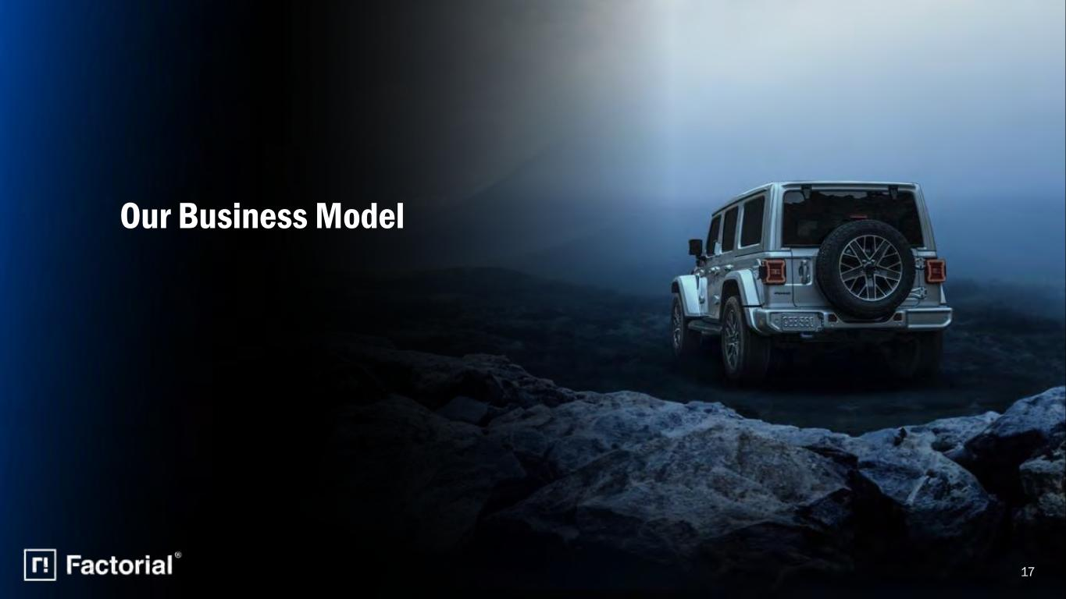
17 Our Business Model

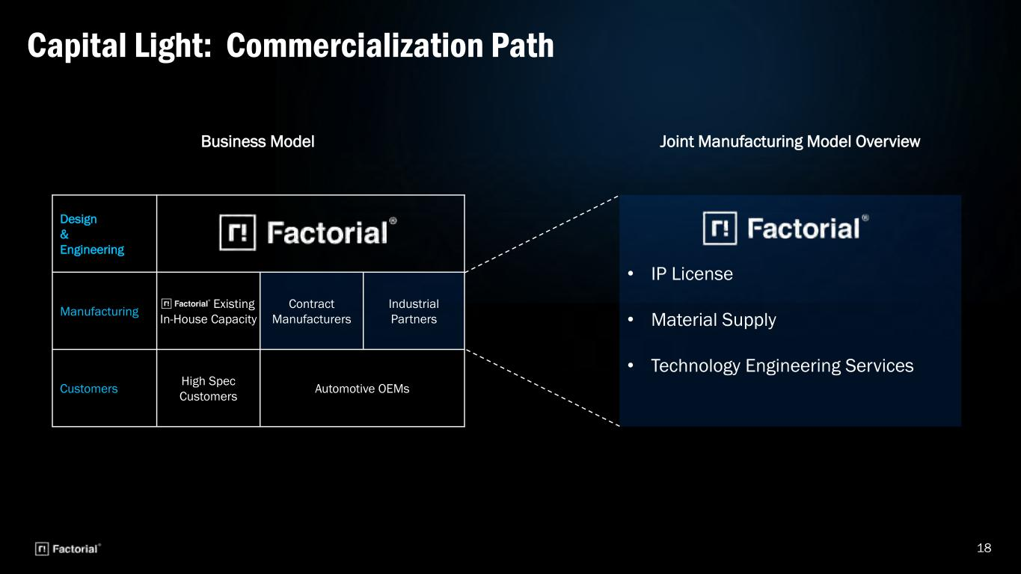
18 Capital Light: Commercialization Path Business Model Design & Engineering Manufacturing Existing In-House Capacity Contract Manufacturers Industrial Partners Customers High Spec Customers Automotive OEMs Joint Manufacturing Model Overview • IP License • Material Supply • Technology Engineering Services

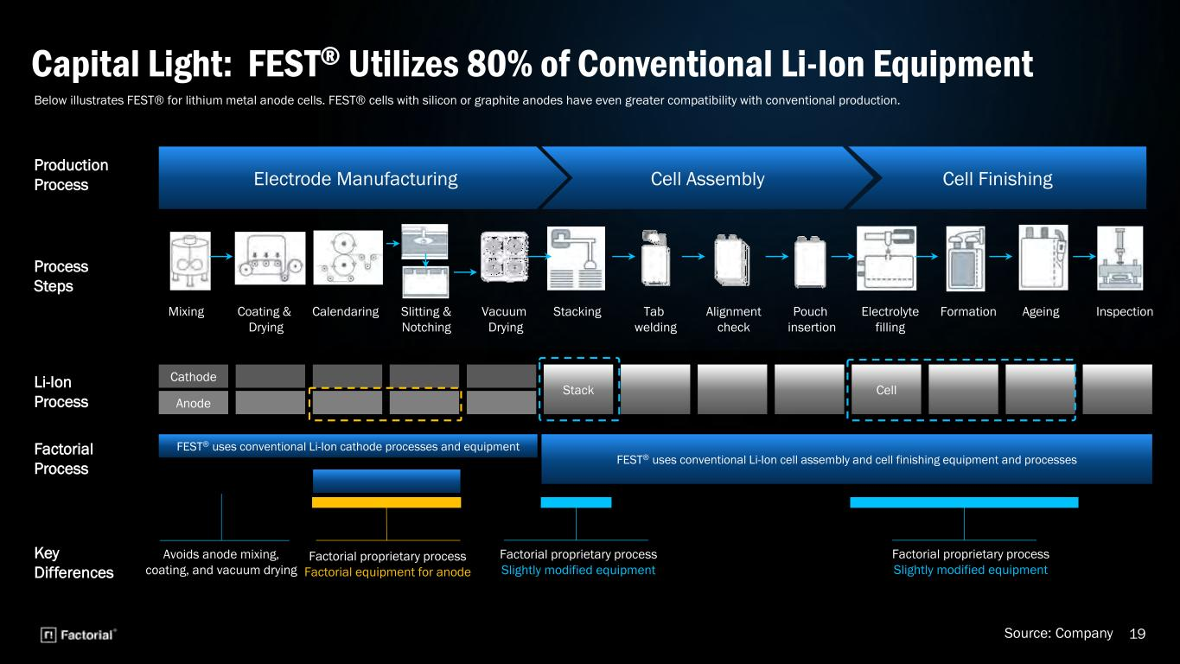
19 Capital Light: FEST® Utilizes 80% of Conventional Li-Ion Equipment Electrode Manufacturing Cell Assembly Production Process Process Steps Li-Ion Process Factorial Process Cell Finishing CellStack Cathode Anode FEST® uses conventional Li-Ion cell assembly and cell finishing equipment and processes FEST® uses conventional Li-Ion cathode processes and equipment Key Differences Mixing Coating & Drying Calendaring Slitting & Notching Vacuum Drying Stacking Tab welding Alignment check Pouch insertion Electrolyte filling Formation Ageing Inspection Factorial proprietary process Factorial equipment for anode Factorial proprietary process Slightly modified equipment Factorial proprietary process Slightly modified equipment Avoids anode mixing, coating, and vacuum drying Source: Company Below illustrates FEST® for lithium metal anode cells. FEST® cells with silicon or graphite anodes have even greater compatibility with conventional production.

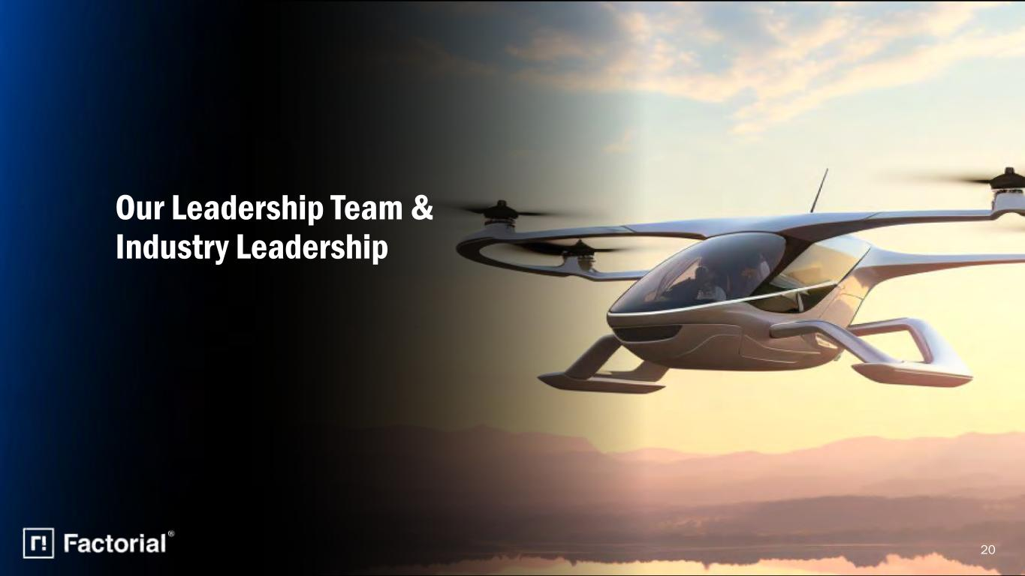
20 Our Leadership Team & Industry Leadership

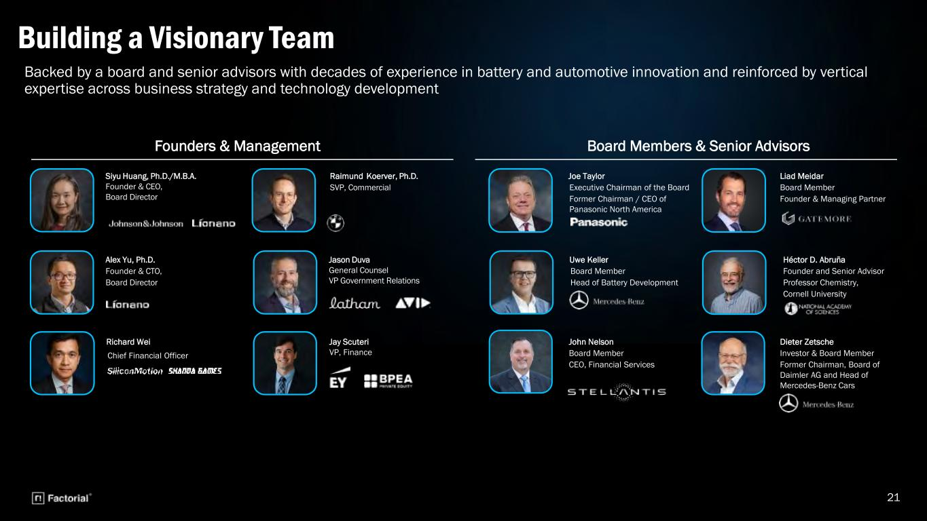
21 Jason Duva General Counsel VP Government Relations Siyu Huang, Ph.D./M.B.A. Founder & CEO, Board Director Alex Yu, Ph.D. Founder & CTO, Board Director Raimund Koerver, Ph.D. SVP, Commercial Joe Taylor Executive Chairman of the Board Former Chairman / CEO of Panasonic North America Héctor D. Abruña Founder and Senior Advisor Professor Chemistry, Cornell University Uwe Keller Board Member Head of Battery Development John Nelson Board Member CEO, Financial Services Dieter Zetsche Investor & Board Member Former Chairman, Board of Daimler AG and Head of Mercedes-Benz Cars Liad Meidar Board Member Founder & Managing Partner Founders & Management Board Members & Senior Advisors Richard Wei Chief Financial Officer Backed by a board and senior advisors with decades of experience in battery and automotive innovation and reinforced by vertical expertise across business strategy and technology development Building a Visionary Team Jay Scuteri VP, Finance

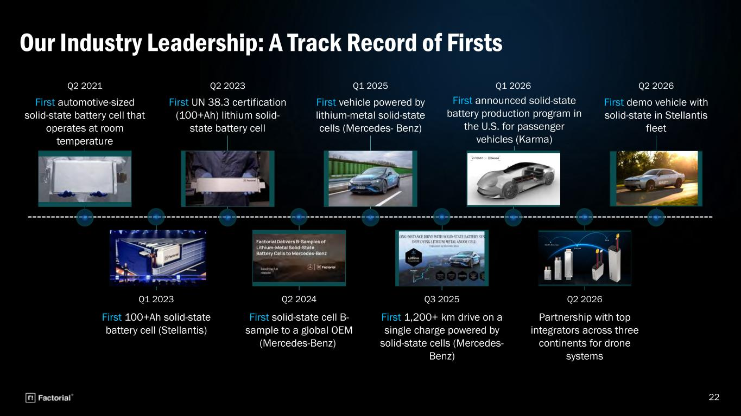
22 Our Industry Leadership: A Track Record of Firsts Q2 2021 Q2 2023 First UN 38.3 certification (100+Ah) lithium solid- state battery cell Q1 2025 First vehicle powered by lithium-metal solid-state cells (Mercedes- Benz) Q1 2026 First announced solid-state battery production program in the U.S. for passenger vehicles (Karma) Q1 2023 First 100+Ah solid-state battery cell (Stellantis) Q2 2024 First solid-state cell B- sample to a global OEM (Mercedes-Benz) Q3 2025 First 1,200+ km drive on a single charge powered by solid-state cells (Mercedes- Benz) Q2 2026 Partnership with top integrators across three continents for drone systems First automotive-sized solid-state battery cell that operates at room temperature Q2 2026 First demo vehicle with solid-state in Stellantis fleet


Conclusion 23

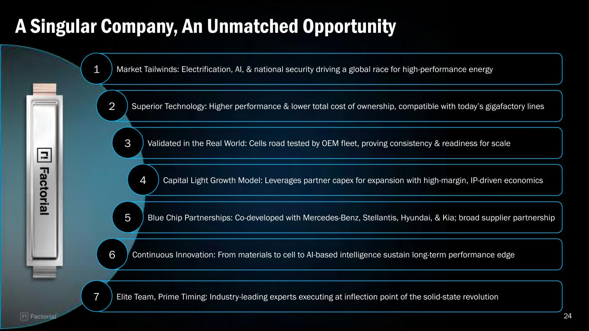
24 A Singular Company, An Unmatched Opportunity Market Tailwinds: Electrification, AI, & national security driving a global race for high-performance energy Superior Technology: Higher performance & lower total cost of ownership, compatible with today’s gigafactory lines Validated in the Real World: Cells road tested by OEM fleet, proving consistency & readiness for scale Capital Light Growth Model: Leverages partner capex for expansion with high-margin, IP-driven economics Blue Chip Partnerships: Co-developed with Mercedes-Benz, Stellantis, Hyundai, & Kia; broad supplier partnership Continuous Innovation: From materials to cell to AI-based intelligence sustain long-term performance edge Elite Team, Prime Timing: Industry-leading experts executing at inflection point of the solid-state revolution 1 2 3 4 5 6 7


Appendix 25

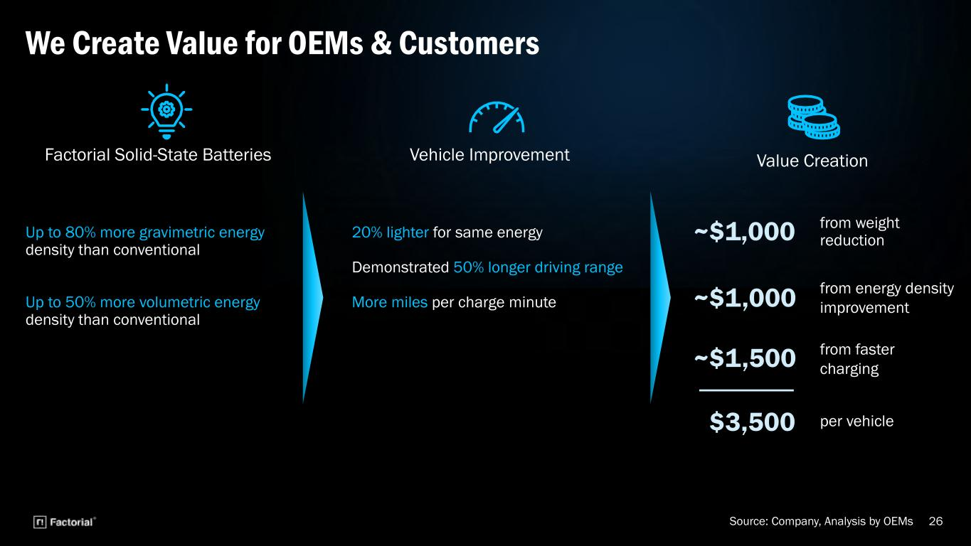
26 Factorial Solid-State Batteries Up to 80% more gravimetric energy density than conventional Up to 50% more volumetric energy density than conventional We Create Value for OEMs & Customers Vehicle Improvement 20% lighter for same energy Demonstrated 50% longer driving range More miles per charge minute from weight reduction~$1,000 ~$1,000 ~$1,500 $3,500 Value Creation from energy density improvement from faster charging per vehicle Source: Company, Analysis by OEMs

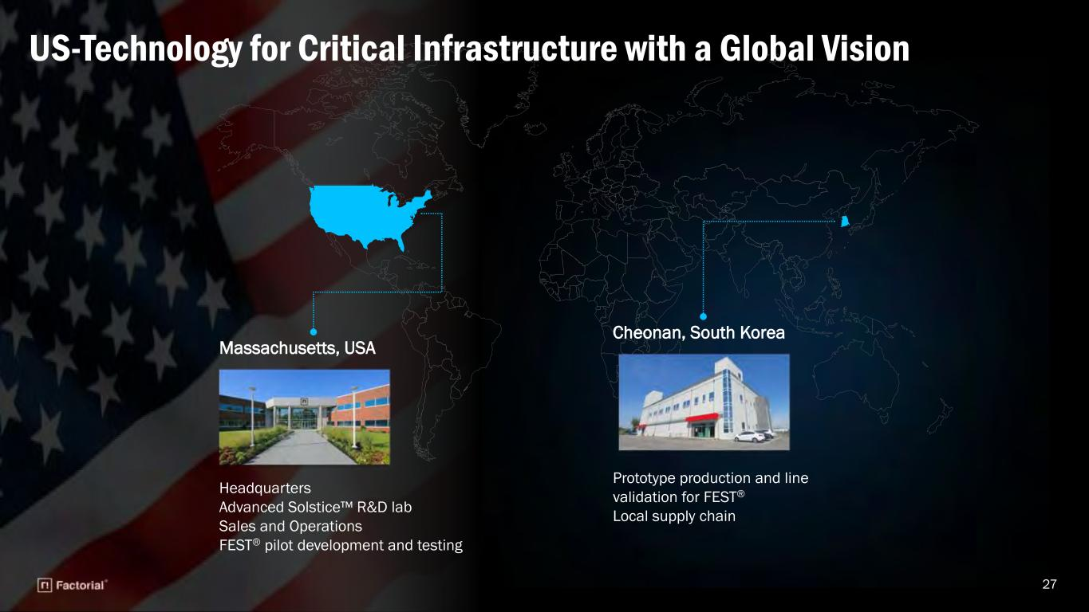
27 Massachusetts, USA Headquarters Advanced Solstice™ R&D lab Sales and Operations FEST® pilot development and testing US-Technology for Critical Infrastructure with a Global Vision Cheonan, South Korea Prototype production and line validation for FEST® Local supply chain

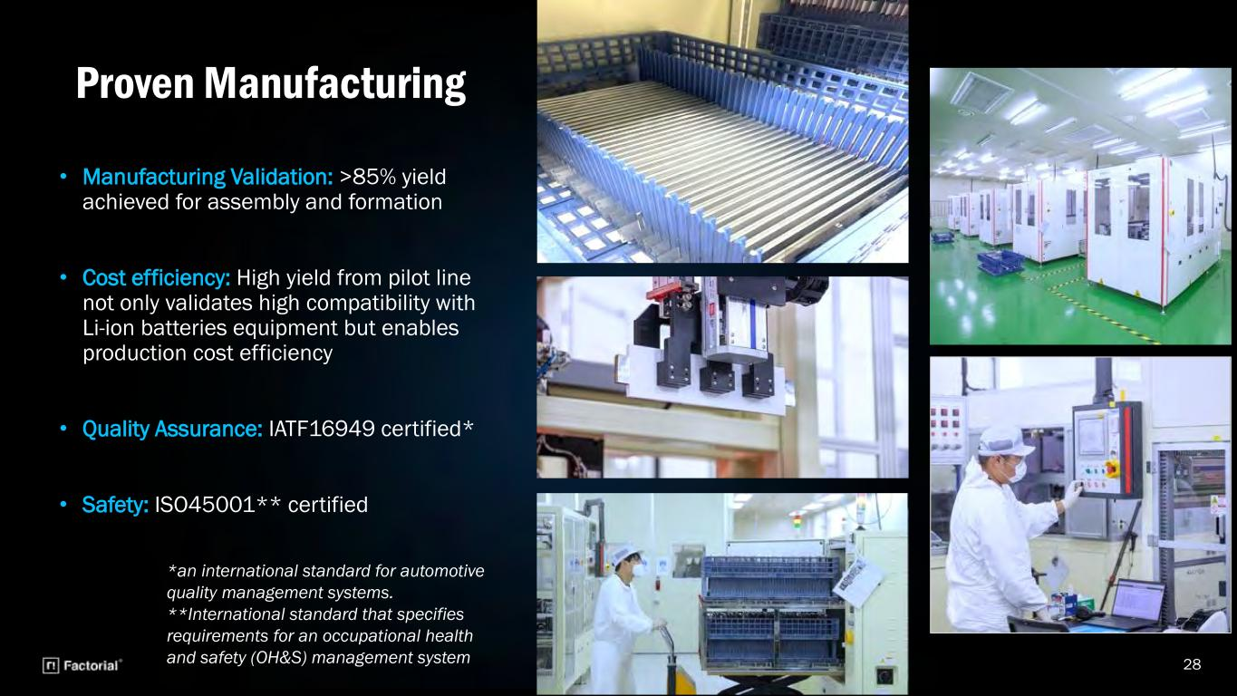
Proven Manufacturing 28 • Manufacturing Validation: >85% yield achieved for assembly and formation • Cost efficiency: High yield from pilot line not only validates high compatibility with Li-ion batteries equipment but enables production cost efficiency • Quality Assurance: IATF16949 certified* • Safety: ISO45001** certified *an international standard for automotive quality management systems. **International standard that specifies requirements for an occupational health and safety (OH&S) management system

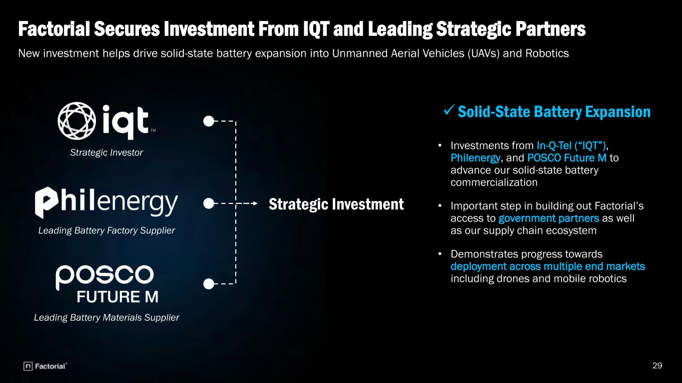
Factorial Secures Investment From IQT and Leading Strategic Partners 29 New investment helps drive solid-state battery expansion into Unmanned Aerial Vehicles (UAVs) and Robotics • Investments from In-Q-Tel (“IQT”), Philenergy, and POSCO Future M to advance our solid-state battery commercialization • Important step in building out Factorial’s access to government partners as well as our supply chain ecosystem • Demonstrates progress towards deployment across multiple end markets including drones and mobile robotics Strategic Investor Leading Battery Factory Supplier Leading Battery Materials Supplier

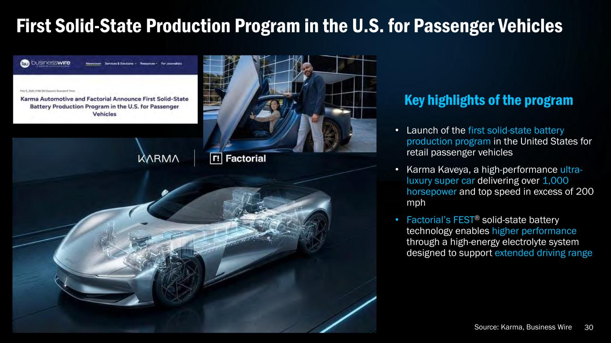
30 • Launch of the first solid-state battery production program in the United States for retail passenger vehicles • Karma Kaveya, a high-performance ultra- luxury super car delivering over 1,000 horsepower and top speed in excess of 200 mph • Factorial’s FEST® solid-state battery technology enables higher performance through a high-energy electrolyte system designed to support extended driving range First Solid-State Production Program in the U.S. for Passenger Vehicles Source: Karma, Business Wire

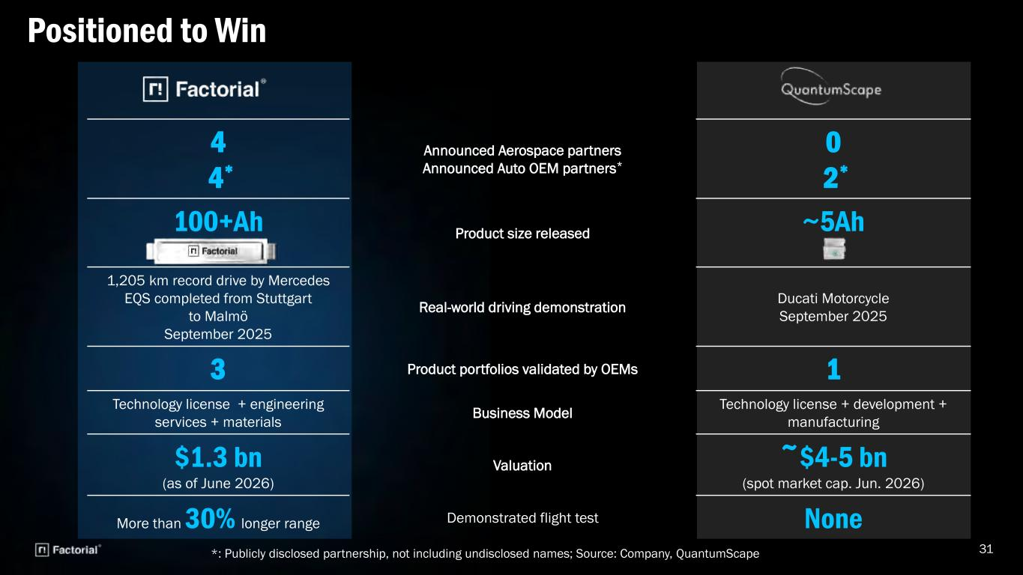
31 Positioned to Win *: Publicly disclosed partnership, not including undisclosed names; Source: Company, QuantumScape 4 4* Announced Aerospace partners Announced Auto OEM partners* 0 2* 100+Ah Product size released ~5Ah 1,205 km record drive by Mercedes EQS completed from Stuttgart to Malmö September 2025 Real-world driving demonstration Ducati Motorcycle September 2025 3 Product portfolios validated by OEMs 1 Technology license + engineering services + materials Business Model Technology license + development + manufacturing $1.3 bn (as of June 2026) Valuation ~$4-5 bn (spot market cap. Jun. 2026) More than 30% longer range Demonstrated flight test None

